Names:- OLABISI BOLUWATIFE BENJAMIN

UKPONMWAN OSARODION EDWARD

OJO JESUSEMILORE DAVID

ADENUGA ADEBAYO ABDUL-GHAFFAR

OSOYE SALEM OLUWAPAMILERIN

**CPISM**

**Project topic:- A1 Uniforms.**

**(HTML PROJECT)**

**Certification**

This is to certify that this project was carried out and documented by

Mr.Hassan

.………………………………………

Project Supervisor Signature/Date

**Table of contents**

CERTIFICATION1

TABLE OF CONTENTS02

DEDICATION……………………………………………………………………………………………………………………….03

ACKNOWLEDGEMENT…………………………………………………………………………………………………………04

E-PROJECT SYNOPSIS…………………………………………………………………………………………………………05

E-PROJECT ANALYSIS…………………………………………………………………………………………………………06

E-PROJECT DESIGN…………………………………………………………………………………………………………07

**-DFD’S**

**-FLOWCHARTS**

**-PROCESS DIAGRAMS**

**-DATABASE DESIGN/STRUCTURE**

SCREENSHOTS………………………………………………………..………………………………………………………08

SOURCE CODE WITH COMMENTS……………………………………………………………………………………07

USER GUIDE…………………………………………………………………………………………………………09

DEVELOPERS GUIDE…………………………………………………………………………………………………………10

**-MODULE DESCRIPTIONS**

**Dedication**

This project is dedicated to Almighty **GOD** for his ever sufficient strength, grace and understanding to complete this project. we also dedicate this project to our Parents for their ever strong and loving support in building a bright future for me, may GOD continue to bless them and sustain their lives.

**Aknowledgements**

Our sincere gratitude goes to Almighty GOD WHO was, WHO is and who is to continue being there for me.

immeasurable thanks go to our parents, guardians, other people that made impact to I mode of career. Thank you for encouraging and assisting us through the completion of this programme.

Also we wish to express our profound gratitude to our project supervisor, Mr. Hassan who generously helped us by directing us on this write-up and implementation with the tiles of his Knowledge and expertise.

Lastly, we want to express our profound gratitude to Mr. Philips and all our other course mates who assisted us in one way or the other during the implementation of this project.

We say thank you and God bless you all.

**E-project synopsis**

**Homepage:**

Welcome to A1 Uniforms Shop, your one-stop destination for high-quality and comfortable school uniforms. Our homepage greets you with a vibrant display of our latest collections, featuring a diverse range of uniforms that cater to the unique needs of students. Navigate with ease, explore our offerings, and experience the convenience of shopping for school attire online.

**Products Page:**

Dive into our extensive collection of school uniforms on the Products page. With a user-friendly interface, you can easily browse through a variety of items such as P.T. shirts, P.T. shorts, shirts, skirts, P.T. track pants, logos, socks, frocks, belts, and ties. To enhance your shopping experience, utilize our efficient filter section, allowing you to refine your search based on specific uniform categories. Find the perfect fit for your school's dress code effortlessly.

**Filter Section:**

P.T. T-Shirts: Explore a range of Physical Training shirts suitable for various activities.

P.T. Shorts: Comfortable and durable shorts designed for Physical Training sessions.

Shirts: Formal and casual shirts available in different styles and colors.

Skirts: Stylish and well-crafted skirts that adhere to school dress codes.

P.T. Track Pants: Athletic and comfortable track pants suitable for Physical Training.

Logos: Customize your uniforms with school logos and emblems.

Socks: High-quality socks in different styles for everyday wear.

Frocks: Adorable and age-appropriate frocks for younger students.

Belts: Classic and adjustable belts to complement school uniforms.

Ties: Elegant ties that complete the formal uniform look.

**About Us Page:**

Discover the story behind A1 Uniforms Shop. Our About Us page provides insights into our commitment to delivering top-notch school uniforms. Learn about our dedication to quality, ethical manufacturing, and our mission to make the uniform shopping experience convenient and enjoyable for parents, students, and schools alike.

**Contact Us Page:**

Have questions or need assistance? Our Contact Us page is designed for easy communication. Reach out to our friendly and knowledgeable customer support team through the provided contact form, email, or phone number. Your inquiries and feedback are valuable to us, and we are here to ensure your satisfaction with our products and services.

**E-project Analysis**

Website Analysis: [A1 Uniforms Shop]

**User-Friendly Interface:** The homepage of A1 Uniforms Shop boasts a visually appealing and intuitive design, providing a warm welcome to visitors. Navigating through the website is seamless, with clear calls to action and strategically placed menus, ensuring an overall user-friendly experience.

**Product Page and Filter Section:** The Products page stands out for its comprehensive selection of school uniforms, catering to a diverse range of needs. The inclusion of a filter section significantly enhances the user experience, allowing customers to streamline their search for specific items such as P.T. shirts, skirts, or ties. This feature demonstrates a keen understanding of customer convenience.

**Product Diversity:** The website showcases an impressive variety of school uniform items, addressing both formal and casual dress requirements. From P.T. track pants to stylish frocks, the diverse range of products caters to students of all ages and ensures that the website remains a one-stop shop for all school uniform needs.

**Customization Options:** The availability of customization options, such as adding school logos or emblems, adds a personal touch to the shopping experience. This feature is likely to resonate well with schools aiming to maintain a unique identity through their uniforms.

**About Us Page:** The About Us page provides valuable insights into the brand's values and commitment to quality. By sharing the brand story, A1 Uniforms Shop establishes a connection with customers, instilling confidence in the reliability and authenticity of the products.

**Contact Us Page:** The Contact Us page is an essential element of the website, facilitating effective communication between the brand and its customers. The inclusion of multiple contact options, including a contact form, email, and phone number, reflects a commitment to customer support and satisfaction.

**Responsive Design:** The website is optimized for various devices, ensuring a consistent and enjoyable browsing experience across desktops, tablets, and smartphones. This responsiveness contributes to accessibility, accommodating users with different preferences and devices.

**Loading Speed:** The website demonstrates commendable loading speed, preventing potential user frustration. Fast-loading pages contribute to a positive user experience and can positively impact search engine rankings.

**Security Measures:** It's crucial to ensure that the website employs secure payment gateways and data protection measures, especially when dealing with customer transactions. Implementing and highlighting these security features can enhance customer trust.

In conclusion, A1 Uniforms Shop excels in creating an engaging and efficient online platform for school uniform shopping. By combining a user-friendly interface, diverse product offerings, and a commitment to customer satisfaction, the website positions itself as a reliable and convenient solution for parents, students, and schools alike.

**E-project Design**

**DFD’S**

**Level 0 DFD**

**user**

**FLOWCHART**

Contact us page

Product page

About us page

Home page

About us section

Opening hours section

Six P.T. T-shirts with their names and prices

P.T. T-Shirt section

Six frocks with their names and prices

Frocks section

six skirts with their names and prices

Skirts section

six shirts with their names and prices

Shirts section

filter section

footer section

contact section

Aboutus section

eight products

product section

footer section

Address section

map section

footer section

P.T. Shorts section

**Continuation of FLOWCHART-**

footer section

six socks with their names and prices

Socks section

six logos with their names and prices

Logos section

six ties with their names and prices

Ties section

six belts with their names and prices

Belts section

Six P.T. Track pants with their names and prices

P.T. Track pants section

**PROCESS DIAGRAMS**

Start contact page)

Start (Home page)

Start (Home page)

Start (product page)

Start (Home page)

Start (Home page)

Start (Home page)

Start (Home page)

Start (Home page)

Display footer(Home page)

Start (Home page)

Invoke message pageart (Home page)

Start (Home page)

Display send us a message link(Home page)

Start (Home page)

Display contact page contentsStart (Home page)

Start (Home page)

Display P.T. shorts category with six P.T. shorts,name,priceStart (Home page)

Display filter button with filter sectionStart (Home page)

Start (Home page)

Display P.T. T-shirts category with six P.T. T-shirts,name,priceStart (Home page)

Display frock category with six frocks,name,price (Home page)

Start (Home page)

Display skirt category with six skirts,name,price.art (Home page)

Start (Home page)

Display shirt category with six shirts,name,pricetart (Home page)

Start (Home page)

End homepageStart (Home page)

Display footer section with contents e.g(links)aand so on.me page)

Start (Home page)

Display contact us section with opening/closing times, and “send a message” link (Home page)

Start (Home page)

Display about us section with necessary contentsart (Home page)

Start (Home page)

Display products section with six productstart (Home page)

Start (Home page)

Display welcome text and imageStart (Home page)

Start (Home page)

End contact us pageHome page)

Start (Home page)

**Continuation of PROCESS DIAGRAMS**

Display footer(Home page)

Start (Home page)

End about us pageHome page)

Start (Home page)

Display about us page contentsStart (Home page)

Start (Home page)

Start about us page

Start (Home page)

Start (Home page)

End product page (Home page)

Display footer(Home page)

Display socks category with six socks,name,priceStart (Home page)

Display logo category with six logos,name,priceStart (Home page)

Display tie category with six ties,name,priceStart (Home page)

Display Belt category with six belts,name,priceStart (Home page)

Display P.T. trackpant category with six P.T. trackpants,name,priceStart (Home page)

**Screen shots**

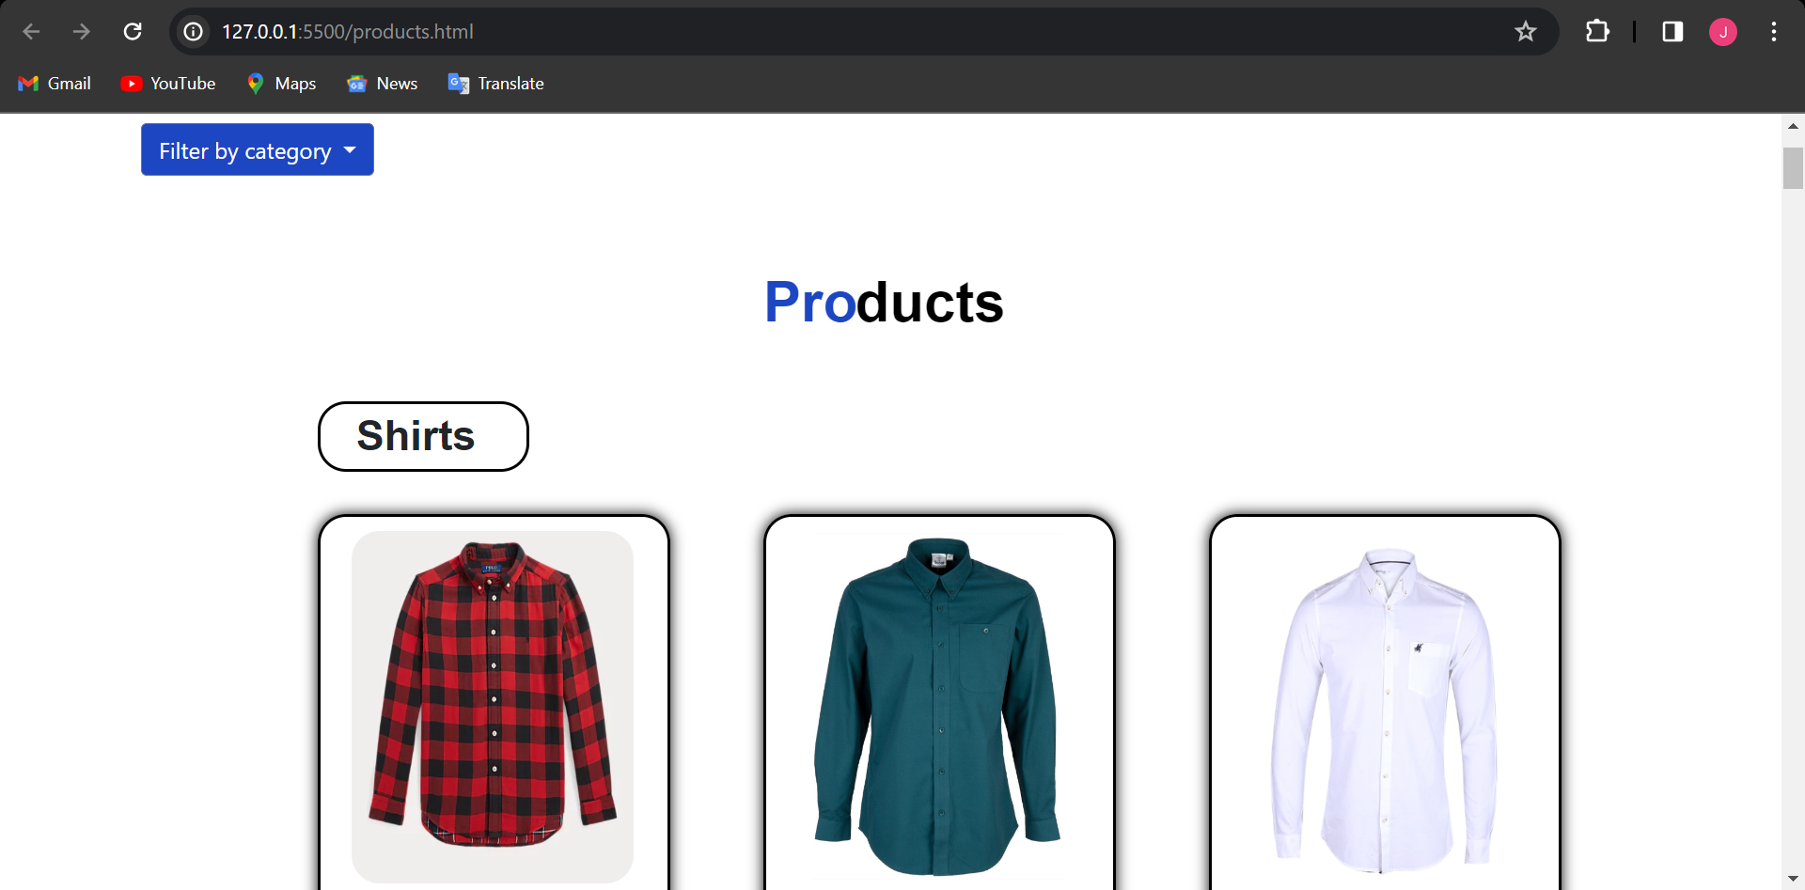

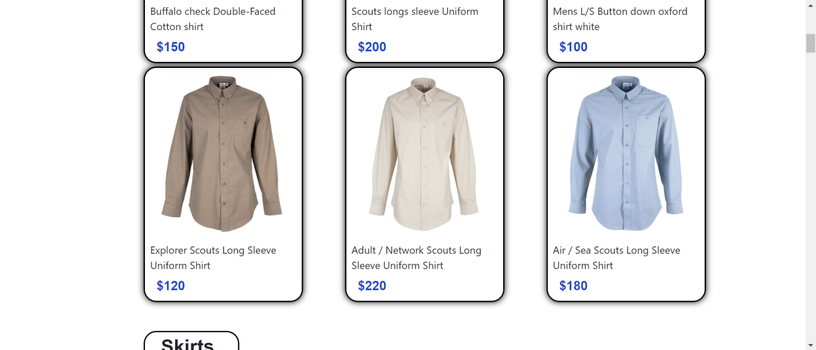

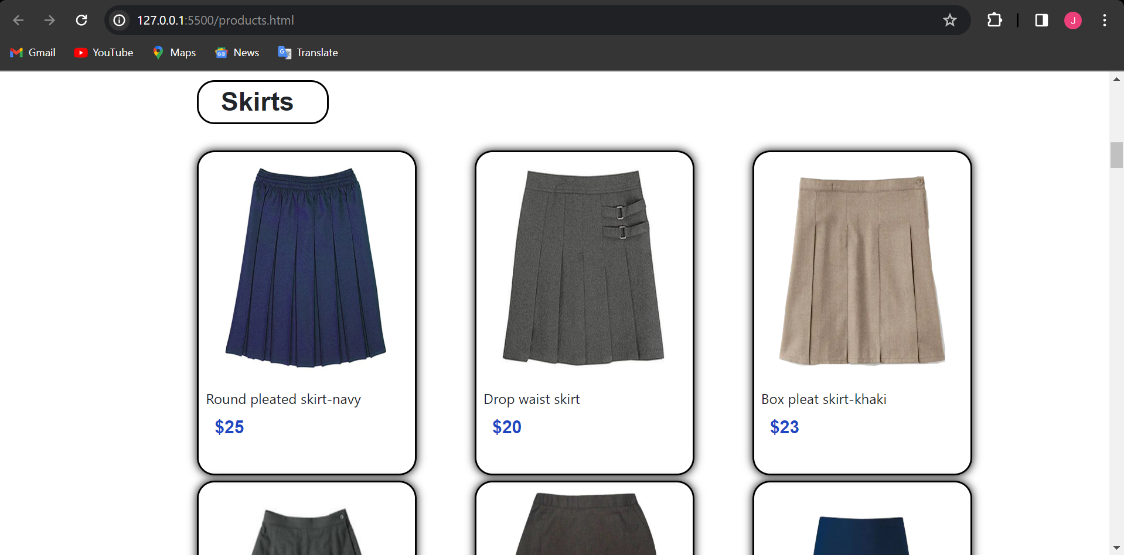

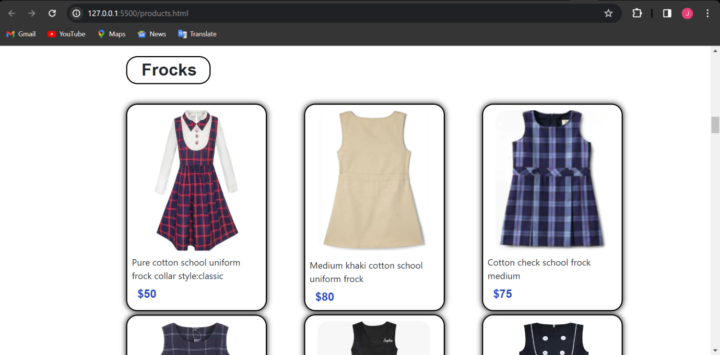

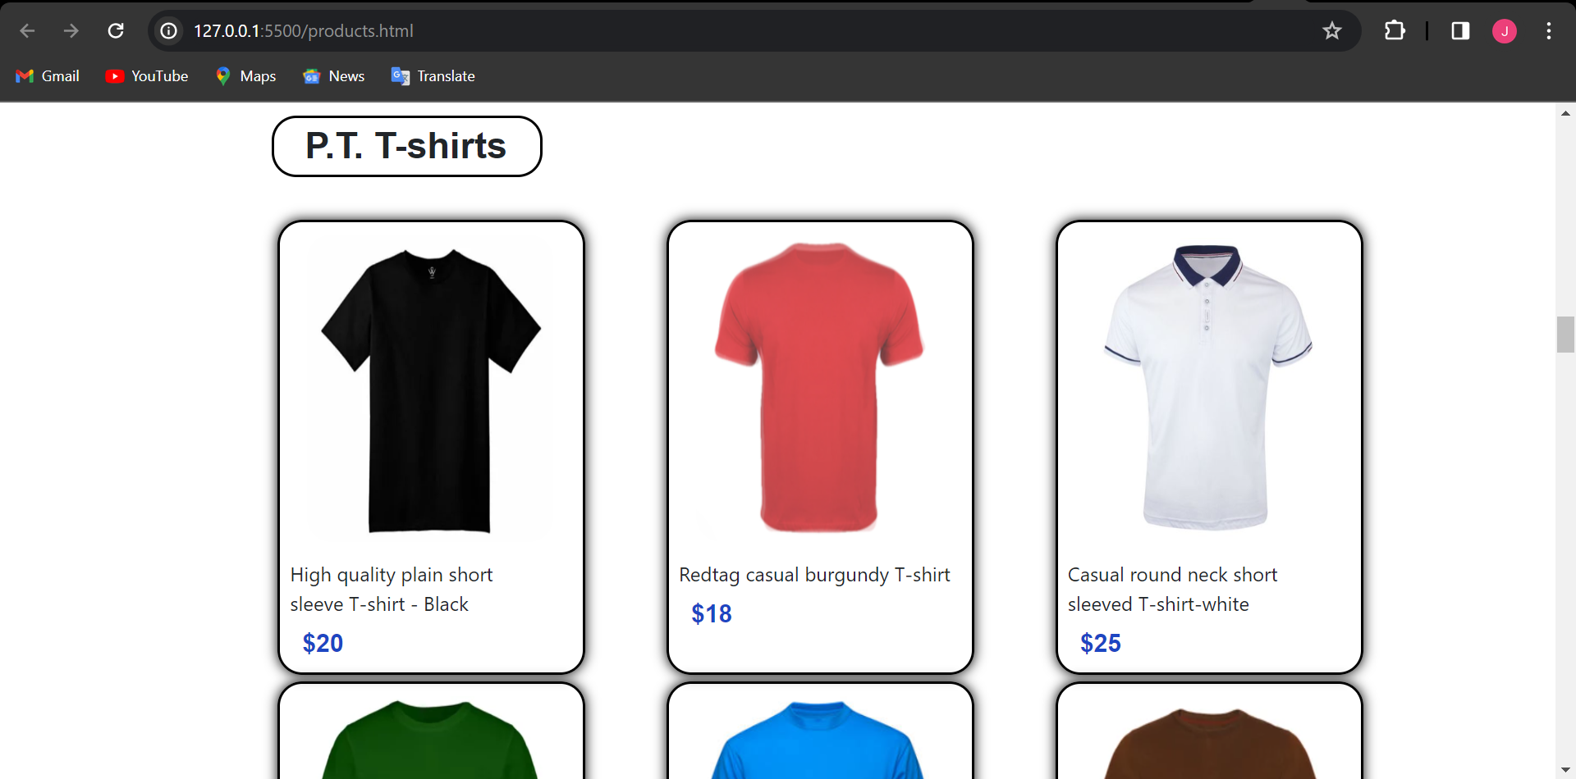

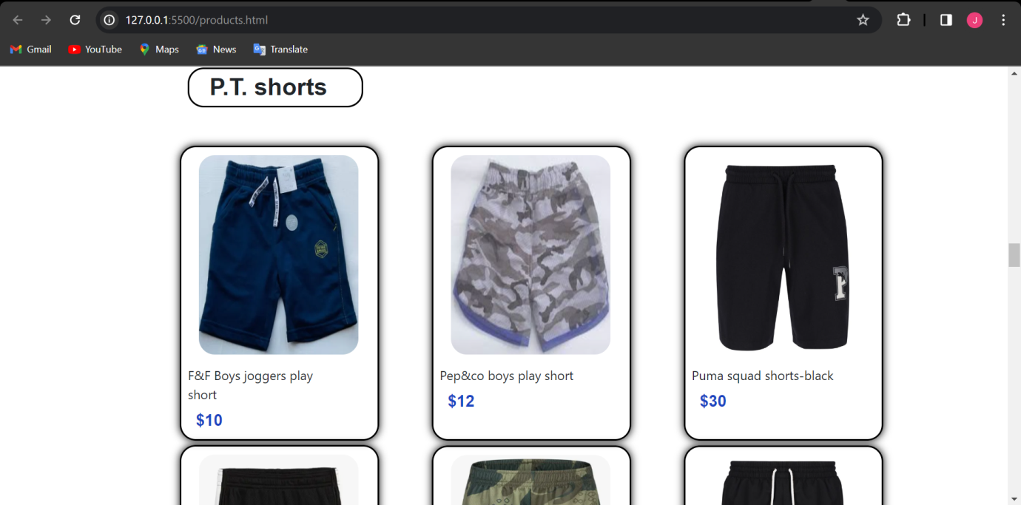

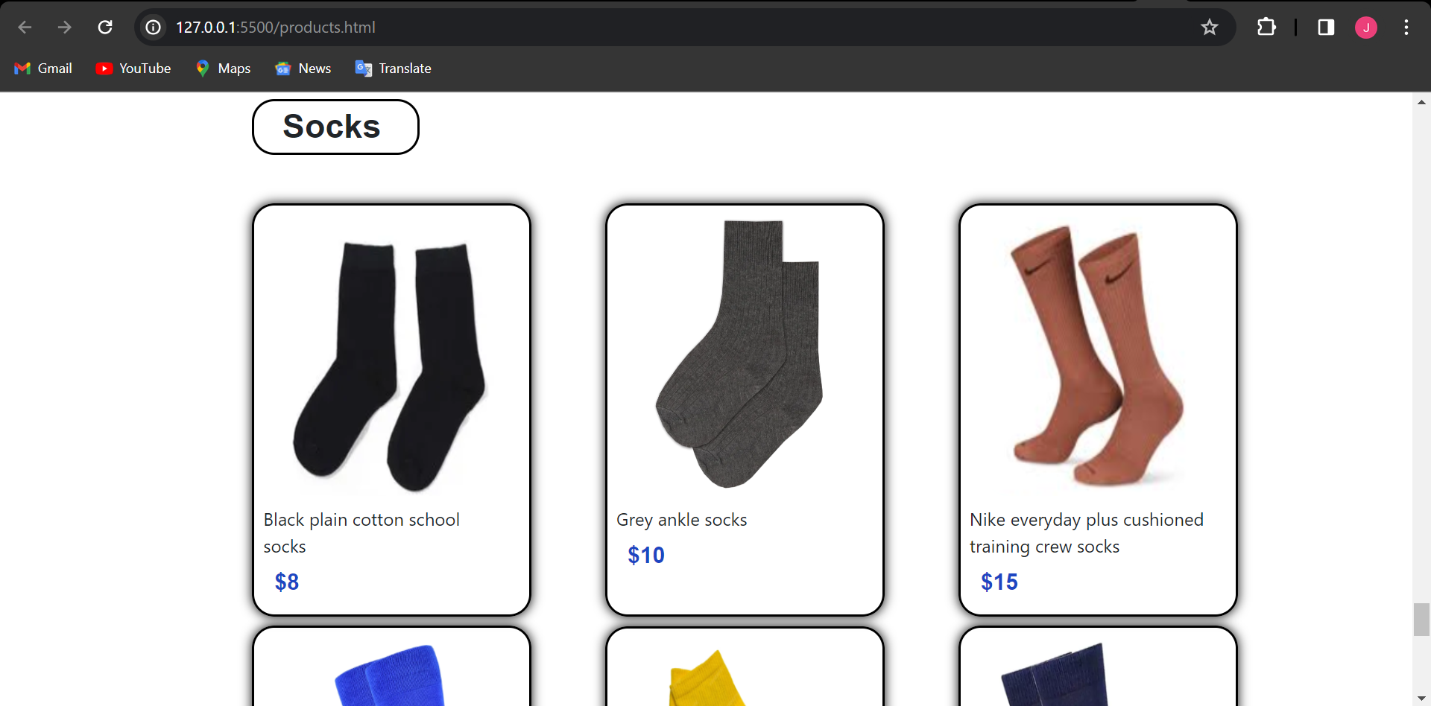

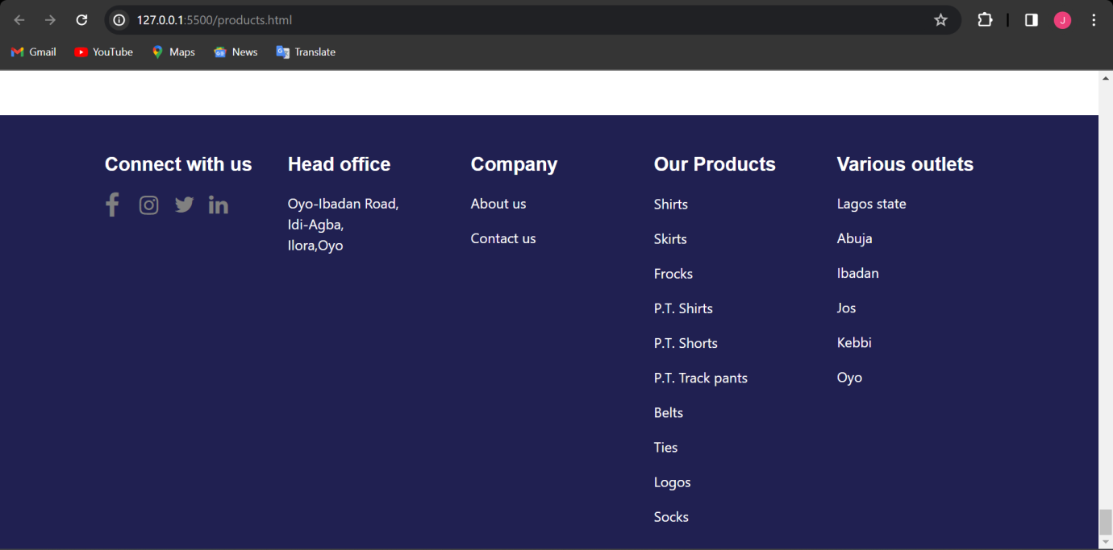

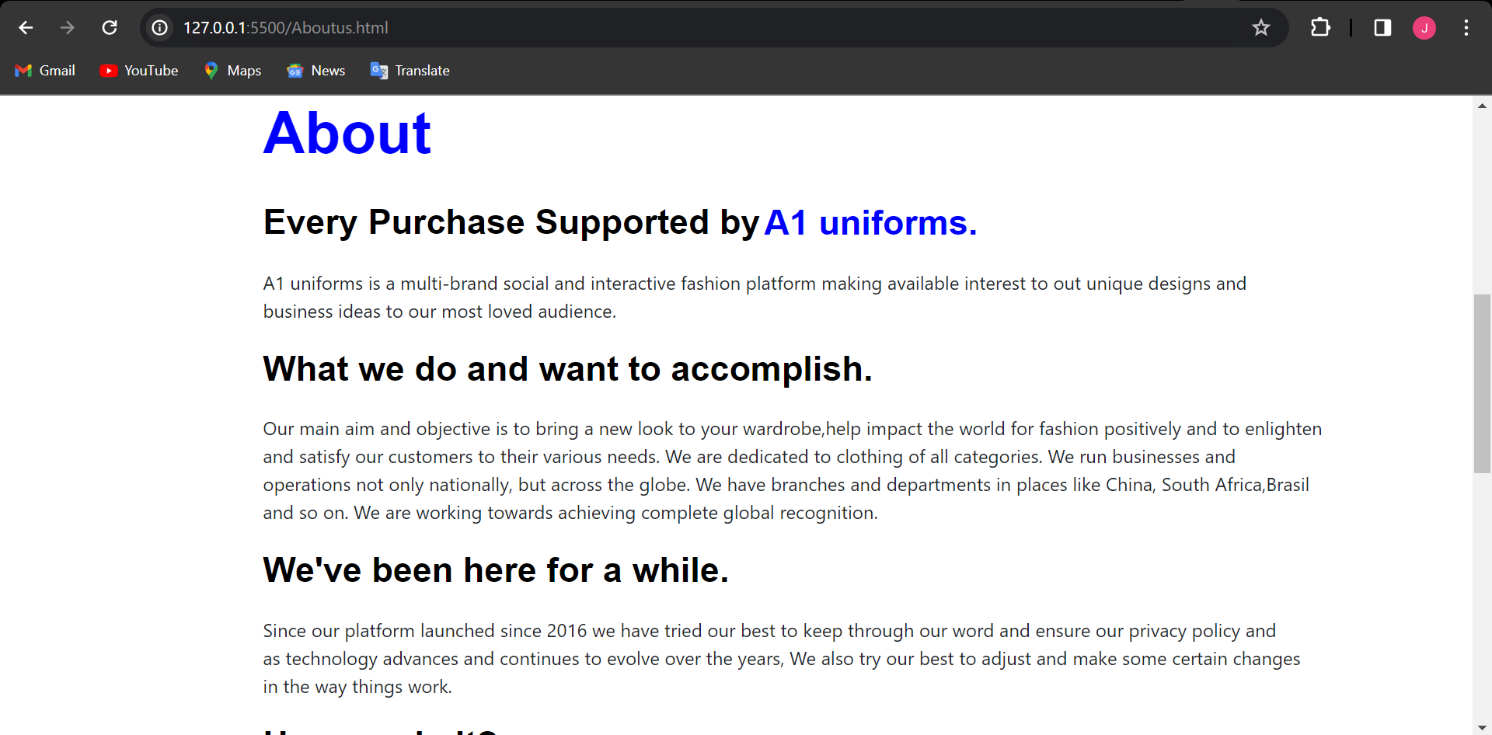

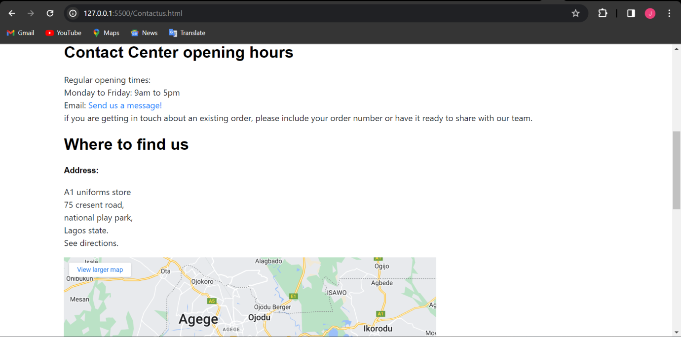

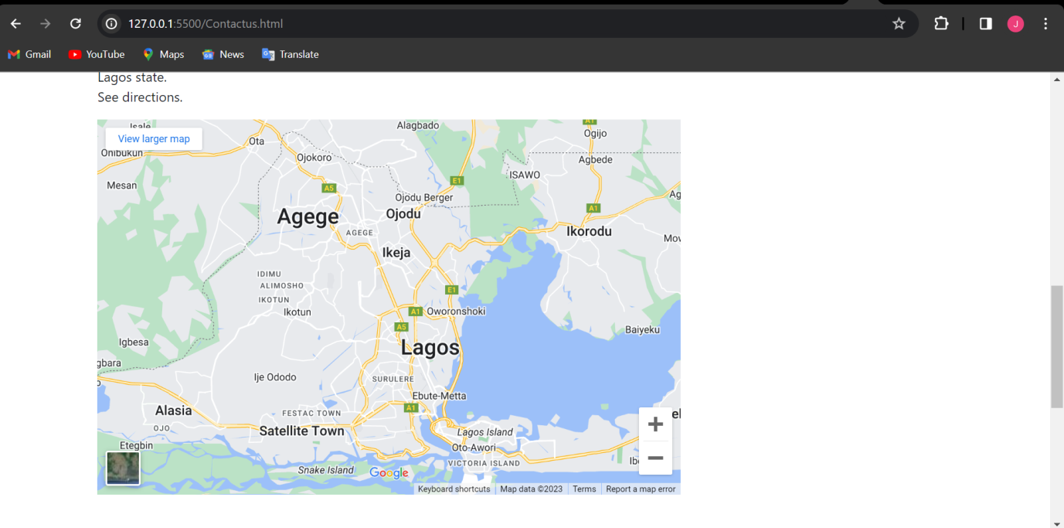

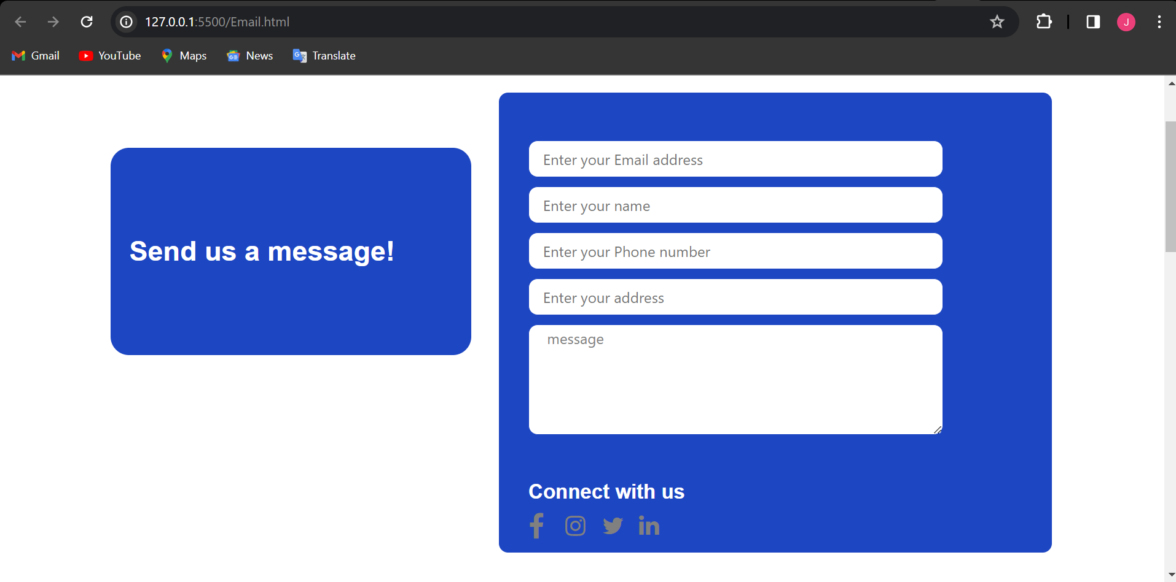

**Source code with comments**

**(Html source code for home page)**

<!DOCTYPE html>

<html lang="en">

<head>

    <meta charset="UTF-8">

    <meta name="viewport" content="width=device-width, initial-scale=1.0">

    <title>A1 Uniforms</title>

    <link rel="stylesheet" href="css/style1.css">

    <link rel="stylesheet" href="https://cdnjs.cloudflare.com/ajax/libs/font-awesome/4.7.0/css/font-awesome.min.css">

    <link rel="stylesheet" href="https://cdn.jsdelivr.net/npm/bootstrap@4.6.2/dist/css/bootstrap.min.css">

    <script src="https://cdn.jsdelivr.net/npm/jquery@3.6.4/dist/jquery.slim.min.js"></script>

    <script src="https://cdn.jsdelivr.net/npm/popper.js@1.16.1/dist/umd/popper.min.js"></script>

    <script src="https://cdn.jsdelivr.net/npm/bootstrap@4.6.2/dist/js/bootstrap.bundle.min.js"></script>

   <script src="https://cdn.jsdelivr.net/npm/bootstrap@4.6.2/dist/js/bootstrap.bundle.min.js"></script>

</head>

<body>

    <div class="container-fluid container1">

    </div>

    <div class="container-fluid container2">

      <div class="row">

          <div class="col-md-1"></div>

          <div class="col-md-2">

              <img src="images/logo.jpg"  class="logo" width="100">

          </div>

          <div class="anchor">

          <div class="col-md-7">

              <a class="hom" href="Home.html"><i class="fa fa-fw fa-home"></i>HOME</a>

              <a class="hom" href="products.html"> <i class="fa solid fa-Shop"></i>PRODUCTS</a>

              <a class="hom" href="about.html">ABOUT US</a>

              <a class="hom" href="contact.html">CONTACT US</a>

 <div class="regfrm">

              <a class="ho" href="prinfo/sig.html">Sign in</a>

              <a class="ho" href="prinfo/reg.html">Register</a>

            </div>

          </div>

          </div>

          <div class="col-md-3">

          </div>

          </div>

      </div>

  </div>

 <div class="container-fluid containerr">

    <div class="row">

        <div class="col-md-1 "></div>

        <div class="col-md-6 container3">

        <h1 class="sch">School Uniforms</h1>

        <p class="from">From sweatshirts and trouers, to shirts and accessories we've got you covered</p>

    <p class="shop">Shop now!</p>

        </div>

        <div class="col-md-4">

            <img src="images/download.jpg"  class="sidimg">

        </div>

        <div class="col-md-1"></div>

    </div>

 </div>

  <h1 class="Mshop"><span class="pro">OUR PRO</span>DUCTS</h1>

 <div class="anchor2">

    <div class="row">

</div>

<div class="container-fluid container4">

    <div class="row">

        <div class="col-md-1">

        </div>

        <div class="col-md-3">

            <button class="price"> Price </button>

            <button class="price"> Size</button>

            <button class="price"> <i class="fa fa-plus"></i> All filters</button>

        </div>

        <div class="col-md-4"> </div>

        <div class="col-md-3">

            <p>4 Products</p><p> Sort by</p>

        </div>

    </div>

</div>

<div class="container-fluid container5">

    <div class="row">

        <div class="col-md-2"></div>

        <div class="col-md-2 box1">

          <img src="/images/OIP.jpg"  class="shirt1">

<h6 class="drc1"> WHITE AND BLUE LONG SLEEVE SHIRTS - TWIN PACK (7021)</h6>

          <h6 class="pr1">$120</h6>

        </div>

        <div class="col-md-2 box1">

             <img src="images/tia1.jpg"  class="shirt3">

            <h6 class="drc1"> SCHOOL TIE ON ELASTIC </h6>

                      <h6 class="pr2">£16.00</h6>

            </div>

        <div class="col-md-2 box1">

            <img src="images/s2.jpg"  class="shirt2">

            <h6 class="drc1"> SCHOOL SHIRTS LONG SLEEVE BLUE</h6>

                      <h6 class="pr3">£26.00</h6>

        </div>

        <div class="col-md-2 box1">

            <img src="images/s3.jpg"  class="shirt2">

            <h6 class="drc1"> SCHOOL SHIRTS SHORT SLEEVE BLUE</h6>

                      <h6 class="pr3">£26.00</h6>

        </div>

        <div class="col-md-1"></div>

    </div>

</div>1

<div class="container-fluid container6">

    <div class="row">

        <div class="col-md-2"></div>

        <div class="col-md-2 box1">

          <img src="images/t1.jpg"  class="t1">

          <h6 class="drc1"> SENIOR BOYS' FIT SLIM TROUSERS </h6>

          <h6 class="pr1">£17.00</h6>

        </div>

        <div class="col-md-2 box1">

             <img src="images/t2.jpg"  class="t1">

            <h6 class="drc1"> SCHOOL BLACK SHORTS</h6>

                      <h6 class="pr6">£16.00</h6>

            </div>

        <div class="col-md-2 box1">

            <img src="images/t3.jpeg"  class="shirt2">

            <h6 class="drc1"> JUNIOR SCHOOL TROUSERS (LONG)</h6>

                      <h6 class="pr1">£26.00</h6>

        </div>

        <div class="col-md-2 box1">

            <img src="images/t-s2.jpg"  class="shirt2">

            <h6 class="drc1"> SCHOOL SKIRT SHORT (GREY)</h6>

                      <h6 class="pr6">£26.00</h6>

        </div>

        <div class="col-md-1"></div>

    </div>

</div>

    <div class="container-fluid container8">

    </div>

 </div>

 <div class="container-fluid">

  <div class="row">

    <div class="col-md-12">

      <h1 class="pro1"> <span class="Mshop">ABOUT </span>US</h1>

     </div>

      </div>

      </div>

 <div class="container-fluid container"></div>

 <div class="container-fluid container5">

    <div class="row">

      <div class="col-md-12">

        <h3 style="font-size: 30px; font-weight: 900; ; text-align: left; margin-left: 110px; margin-top: 15px;">Every Purchase supported by <span>A1 Uniforms.</span></h3>

        <h5 style="text-align: left;font-size: 20px; margin-left: 110px;">A1 Uniforms is a multi-brand social and interactive fashion platform making available interest to out unique designs and business ideas to our most loved audience.</h5>

        </div>

      </div>

    </div>

    <div class="container-fluid container6">

      <div class="row">

          <div class="col-md-12">

            <h4 class="what" style="font-size: 30px; font-weight: 900; margin-left: 110px; margin-top: 15px;">What we do and want to accomplish.</h4>

            <h5 style="text-align: left; font-size: 20px; margin-left: 110px;">Our main aim and objective is to bring a new look to your wardrobe,help impact the world for fashion positively and to enlight and satisfy our customers to their various needs.We are dedicated to clothing of all categories.We run businesses and operations not only naionally,but across the globe.We have branches and deparments in places like China,South Africa,Brasil and so on.We are working towards acheiving complete global reconigition.</h5>

          </div>

        </div>

      </div>

      <div class="container-fluid container6">

        <div class="row">

            <div class="col-md-12">

              <h4 class="what" style="font-size: 30px; font-weight: 900; margin-left: 110px; margin-top: 15px;">We've been here for a while.</h4>

              <h5 style="text-align: left; font-size: 20px; margin-left: 110px;">Since our platform lauched since 2013 we have tried our best to keep through to our word and ensure our privacy policy and as technology advances and continues to evolve over the years,we also try our best to adjust and make some certain changes in the way things work</h5>

            </div>

          </div>

        </div>

        <div class="container-fluid container6">

          <div class="row">

              <div class="col-md-12">

                <h4 class="what" style="font-size: 30px; font-weight: 900; margin-left: 110px; margin-top: 15px;">How we do it?</h4>

                <h5 style="text-align: left; font-size: 20px; margin-left: 110px;">We ensure our clothing exceeds the expectation for our customers.We also want to enure the there is no difficult moment in your time with us.We make use of quality material to ensure our clothingis to our best fit and research daily to improve our products and franchise.</h5>

              </div>

            </div>

          </div>

        <div class="container-fluid container6">

          <div class="row">

              <div class="col-md-12">

                <h4 class="what" style="font-size: 30px; font-weight: 900; margin-left: 110px; margin-top: 15px;">How to find us.</h4>

                <h5 style="text-align: left; font-size: 20px; margin-left: 110px;">We have different sectors in different areas.You could visit the <a href="Contact.html" style="text-decoration: none;">Contact Us</a> page for more info.You could also vist our facebook page @A1 uniforms,then on twitter and instagram,you could check us our @A1 clothing.</h5>

              </div>

            </div>

          </div>

<div class="con">

  <h1 class="pro1"> <span class="Mshop">Contact </span>US</h1>

          <p class="mp">

            Regular opening times:

          <br>

            Monday to Friday: 9am to 5pm

          <br> <br>

          Email us:<a href="mailto:example@example.com">onlinevarsity@gmail.com</a> or click on the “Help” button to chat to us live. </p>

          <p class="mpp"> If you are getting in touch about an existing order, please include your order number or have it ready to share with our team.

          </p>

          <h6 class="contac">Address</h6>

          <p class="mpp">

            Oyo-Ibadan Road,<br>

    Idi-Agba,<br>

    Lagos

          </p>

        </div>

<!--  -->

</body>

</html><div class="container-fluid container7">

    <div class="row">

      <div class="col-md-1"></div>

      <div class="col-md-2">

        <h3 class="cont">Connect With Us </h3>

      <div class="licon">

        <i class="fa fa-facebook"></i>

        <i class="fa fa-instagram"></i>

        <i class="fa fa-twitter"></i>

        <i class="fa fa-linkedin"></i>

       </div>

      </div>

      <div class="col-md-2">

        <h3 class="cont">Head office </h3>

        <p>Oyo-Ibadan Road,<br>

          Idi-Agba,<br>

          Ilora, Oyo</p>

      </div>

      <div class="col-md-2">

        <h3 class="cont"> Company </h3>

        <p>About us <br>

          Join the team <br>

          Contact us <br>

          </p>

      </div>

      <div class="col-md-2">

        <h3 class="cont"> Our Products

        </h3>

        <p>Business Account <br>

  POS Terminals <br>

  Expense Cards <br>

  Working Capital Loans <br>

  Monnify <br>

  </p>

      </div>

      <div class="col-md-2">

        <h3 class="cont"> Resources</h3>

        <p>

          Help Centre <br>

  Learning Centre <br>

  Whistleblower Policy <br>

  Privacy Policy <br>

  Cookie Policy <br>

  IMS Policy <br>

        </p>

      </div>

      <div class="col-md-1"></div>

    </div>

    <div class="feature-dividerr">    </div>

    <div class="row">

      <div class="col-md-3">

      </div>

      <div class="col-md-6">

<p>A1 Uniforms are always avaliable to provide the best clothings <br>From sweatshirts and trouers, to shirts and accessories we've got you covered

 C 2023.

<br>Aptech project</p>

      </div>

      <div class="col-md-3">

        <i class="fa fa-location-pin"></i>

        <i class="fa-solid fa-location-dot"></i>

        <h6>Nigeria</h6>

      </div>

    </div>

   </div>

**(Css source code for home page)**

.container-fluid.container1{

    background-color: rgb(0, 85, 141);

    height: 23px;

    width: 100%;

}

.container2{

    height: 70px;

    width: 100%;

    background-image: linear-gradient( 111.4deg,  rgb(230, 230, 230) 1.5%, rgba(130, 130, 131, 0.664) 93.2% );

}

.logo{

margin-top: 5px;

}

.anchor{

  margin-top: 30px;

    width: 50%;

}

.inp{

    margin-top: -50px;

    background-color: rgb(255, 255, 255);

    border-radius: 10px;

    border: 1px solid black;

}

.hom{

    padding: 20px;

    color: rgb(0, 0, 0);

    font-style: bold;

    font-size: 100%;

    font-family: 'Lucida Sans', 'Lucida Sans Regular', 'Lucida Grande', 'Lucida Sans Unicode', Geneva, Verdana, sans-serif;

}

.regfrm{

    height: 20px;

    width: 50%;

    border-radius: 10px;

    border: 1px solid rgb(131, 131, 131);

    background-color: rgb(81, 131, 165);

    margin-left: 500px;

    margin-top: -20px;

    text-align: center;

}

.ho{

    text-align: center;

    padding-left: 6px;

    color: rgb(255, 253, 253);

    font-style: bold;

    font-size: 100%;

    font-family: 'Lucida Sans', 'Lucida Sans Regular', 'Lucida Grande', 'Lucida Sans Unicode', Geneva, Verdana, sans-serif;

}

.ho:hover{

    color:blue;

    padding: 20px;

    font-size: 125%;

    text-decoration: none

}

.hom:hover{

    color:rgb(38, 0, 255);

    padding: 20px;

    font-size: 120%;

    text-decoration: none

}

.inp{

    margin-top: 30px;

    background-color: rgb(255, 255, 255);

    border-radius: 10px;

    border: 1px solid black;

}

.container3{

    background-color:rgb(0, 66, 141);

    height: 400px;

    width: 100%;

}

.sch{

    color: white;

    font-family: sans-serif;

    font-weight: bolder;

    font-size: 60px;

    line-height: 1.25rem;

     padding-top: 120px;

     padding-left: 20px;

}

.from{

    padding-left: 20px;

    color: white;

    font-weight: bold;

    padding-top: 10px;

}

.shop{

    padding-left: 20px;

    color: white;

    padding-top: 2px;

}

.sidimg{

    width: 110%;

    height: 400px;

}

.hed2{

    padding-top: 30px;

    padding-left: 131px;

    color: rgb(8, 8, 8);

    font-style: bolder;

}

.Mshop{

    color: rgb(0, 0, 0);

    font-family:'Franklin Gothic Medium', 'Arial Narrow', Arial, sans-serif;

    font-weight: bolder;

    font-size: 60px;

    padding-top: 100px;

    margin-bottom: 100px;

}

.pro{

    color:rgb(0, 66, 141);

    font-family:'Franklin Gothic Medium', 'Arial Narrow', Arial, sans-serif;

    font-size: 60px;

    padding-top: 100px;

}

.hr1{

    width: 100%;

    color: rgb(8, 8, 8);

}

.price{

    height: 50px;

    background-color: bisque;

    width: 100px;

border: none;

border-radius: 40px;

}

.container5{

    padding-top: 70px;

}

.box1{

    height: 400px;

    width: 200%;

     border: 0.2px solid black;

     border-radius: 30px;

     margin-right: 15px;

}

.shirt1{

    width: 100px;

   margin-top:30px;

   height: 270px;

}

.drc1{

    margin-top: 15px;

    color: rgb(0, 0, 0);

    margin-left: 10px;

    font-size: 15px;

}

.pr1{

    margin-top: 10px;

    color: rgb(17, 0, 255);

    margin-left: 7px;

    font-size: 15px;

}

.pr2{

    margin-top: 34px;

    color: rgb(17, 0, 255);

    margin-left: 10px;

    font-size: 15px;

}

.pr3{

    margin-top: 15px;

    color: rgb(17, 0, 255);

    margin-left: 7px;

    font-size: 15px;

}

.pr6{

    margin-top: 30px;

    color: rgb(17, 0, 255);

    margin-left: 7px;

    font-size: 15px;

}

.shirt2{

    width: 200px;

   margin-top:10px;

   height: 300px;

}

.container5 {

    border-radius: 20px;

    width: 100%;

}

.container5 img {

    border-radius: 20px;

    width: 100%;

}

.shirt3{

    width: 200px;

   margin-top:10px;

   height: 300px;

   padding: 20px 40px;

}

.container7{

    background: 50% 25% no-repeat rgb(3, 28, 75);

    color: white;

    height: 500px;

    width: 100%;

   margin-top: 100px;

    padding-top: 100px;

    position: relative;

}

.container6{

    margin-top: 100px;

}

.t1{

    width: 200px;

   margin-top:10px;

   height: 300px;

}

.row{

    padding-left: 80px;

}

.hom2{

   margin-top: 100px;

    padding-top: 10px;

     border:1px solid black;

    border-radius: 20px;

    color: rgb(0, 0, 0);

    font-style: bold;

    font-size: 120%;

    font-family: 'Lucida Sans', 'Lucida Sans Regular', 'Lucida Grande', 'Lucida Sans Unicode', Geneva, Verdana, sans-serif;

}

*{

    padding: 0;

    margin: 0;

    font-family: Arial, Helvetica, sans-serif;

}

.container-fluid.container1{

    background-color: rgb(0, 85, 141);

    height: 23px;

    width: 100%;

}

.container2{

    height: 80px;

    width: 100%;

    background-image: linear-gradient( 111.4deg,  rgb(230, 230, 230) 1.5%, rgba(130, 130, 131, 0.664) 93.2% );

}

.logo{

margin-top: 5px;

}

.container3{

    background-color:rgb(0, 66, 141);

    height: 400px;

    width: 100%;

}

.sch{

 color: white;

    font-family: sans-serif;

    font-weight: bolder;

    font-size: 60px;

    line-height: 1.25rem;

     padding-top: 120px;

     padding-left: 20px;

     transition: 0.5s ease-in;

}

.sch:hover{

color: blue;

}

span{

    color: white;

}

.from{

    padding-left: 20px;

    color: white;

    font-weight: bold;

    padding-top: 10px;

}

.shop{

    padding-left: 20px;

    color: white;

    padding-top: 2px;

}

.sidimg{

    width: 110%;

    height: 400px;

}

.container-fluid.containerr{

    animation: FadeIn 3s;

           }

           @keyframes FadeIn {

    0% {

    opacity: 0;

      }

      100%{

        opacity: 1;

      }

           }

 h3 span{

    color: darkblue;

 }

 .ph{

    border: 2px solid black;

    width: 30%;

    height: 40px;

    margin-left: 500px;

 }

 .Join{

color: white;

    background-color: black;

    width: 20%;

    font-size: 20px;

    margin-top: 30px;

        height: 50px;

    border-radius: 30px;

    margin-left: 500px;

 }

 .Mshop{

    color: rgb(0, 0, 0);

    font-family:'Franklin Gothic Medium', 'Arial Narrow', Arial, sans-serif;

    font-weight: bolder;

    font-size: 60px;

    line-height: 1.25rem;

     text-align: center;

}

.pro1{

    color:rgb(0, 66, 141);

    font-family:'Franklin Gothic Medium', 'Arial Narrow', Arial, sans-serif;

    font-weight: bolder;

    font-size: 60px;

    line-height: 1.25rem;

    text-align: center;

    animation: mymove 2s infinite; /* Chrome, Safari, Opera */

    margin-top: 25px;

}

.contac{

    margin-top: 100px;

   margin-left: 120px;

   font-size: 30px;

   font-weight: bolder;

}

.mp{

    margin-left: 120px;

    font-size: 30px;

    width: 100%;

}

.mpp{

    margin-left: 120px;

    font-size: 20px;

    width: 100%;

}

.map{

    margin-top: 100px;

    margin-left:30px;

}

.con{

margin-left: 90px;

margin-top: auto;}

**(html source code for products page)**

<!DOCTYPE html>

<html lang="en">

<head>

    <meta charset="UTF-8">

    <meta name="viewport" content="width=device-width, initial-scale=1.0">

    <title>Document</title>

    <link rel="stylesheet" href="css/style2.css">

    <link rel="stylesheet"  href="https://stackpath.bootstrapcdn.com/font-awesome/4.7.0/css/font-awesome.min.css">

    <link rel="stylesheet" href="https://cdn.jsdelivr.net/npm/bootstrap@4.6.2/dist/css/bootstrap.min.css">

  <script src="https://cdn.jsdelivr.net/npm/jquery@3.6.4/dist/jquery.slim.min.js"></script>

  <script src="https://cdn.jsdelivr.net/npm/popper.js@1.16.1/dist/umd/popper.min.js"></script>

  <script src="https://cdn.jsdelivr.net/npm/bootstrap@4.6.2/dist/js/bootstrap.bundle.min.js"></script>

  <script src="js/a1uniforms.js"></script>

</head>

<body>

    <div class="container-fluid container1">

        <div class="row">

            <div class="col-md-2">

                <!-- <div class="a1uniformstext">

                    <p>A1 Uniforms</p>

                </div> -->

                <div class="A1uniformslogo">

                  <img src="images/A1uniformslogo.png.jpg" alt="A1uniformslogo" height="80" width="110">

                </div>

            </div>

            <nav class="navbar navbar-expand-lg">

                <button class="navbar-toggler" type="button" data-toggle="collapse" data-target="#navbarNav">

                  <i class="fa fa-bars fa-fw"></i>

                </button>

                <div class="collapse navbar-collapse" id="navbarNav">

                    <div class="col-md-1">

                    <div class="Homepagelink">

                      <a class="link1" href="A1uniforms.html">HOME</a>

                    </div>

                </div>

                <div class="col-md-1"></div>

                <div class="col-md-2">

                    <div class="Productspagelink">

                      <a class="link2" href="products.html">PRODUCTS</a>

                    </div>

                </div>

                <div class="col-md-1"></div>

                <div class="col-md-3">

                    <div class="contactuspagelink">

                      <a class="link3" href="Contactus.html">CONTACT US</a>

                    </div>

                </div>

                <div class="col-md-3">

                    <div class="Aboutuspage">

                        <a class="link4" href="Aboutus.html">ABOUT US</a>

                    </div>

                </div>

                </div>

             </nav>

        </div>

    </div>

    <div class="dropdown">

        <button class="btn btn-secondary dropdown-toggle" type="button" id="dropdownMenuButton" data-toggle="dropdown" aria-haspopup="true" aria-expanded="false">

           Filter by category

        </button>

        <div class="dropdown-menu" aria-labelledby="dropdownMenuButton">

           <a class="dropdown-item" href="Shirtfiltersection.html">Shirts</a>

           <a class="dropdown-item" href="Skirtfiltersection.html">Skirts</a>

           <a class="dropdown-item" href="Frockfiltersection.html">Frocks</a>

           <a class="dropdown-item" href="ptTshirtfiltersection.html">P.T. T-Shirt</a>

           <a class="dropdown-item" href="ptShortfiltersection.html">P.T. Short</a>

           <a class="dropdown-item" href="ptTrackpantfiltersection.html">P.T. Track pant</a>

           <a class="dropdown-item" href="Beltfiltersection.html">Belts</a>

           <a class="dropdown-item" href="Tiefiltersection.html">Ties</a>

           <a class="dropdown-item" href="Logofiltersection.html">Logos</a>

           <a class="dropdown-item" href="Sockfiltersection.html">Socks</a>

           <!-- <div class="filter-section">

            <select id="category-dropdown">

                <option value="all">Shirts</option>

                <option value="all">Skirts</option>

                <option value="all">Frocks</option>

                <option value="all">P.T. Shirts</option>

                <option value="all">P.T. Shorts</option>

                <option value="all">P.T. Track pants</option>

                <option value="all">Belts</option>

                <option value="all">Ties</option>

                <option value="all">Logos</option>

                <option value="all">Socks</option>

            </select>

            <div id="product-list">

                <a href="products.html">shirts</a>

            </div>

        </div> -->

           <!-- <a class="dropdown-item" href="#">Filter by Rating</a> -->

        </div>

       </div>

       <!-- <div class="filter-section">

        <select id="category-dropdown">

            <option value="all">All</option>

            Add more category options here

        </select>

        <div id="product-list">

        Products will be displayed here

        </div>

    </div> -->

    <div class="container-fluid container2part2">

        <div class="row"></div>

    </div>

    <div class="container-fluid container3part2">

        <div class="row">

            <div class="col-md-5"></div>

            <div class="col-md-4">

                <div class="Productstext">

                    <p>Pro</p>

                    <p class="ductstext">ducts</p>

                </div>

            </div>

            <div class="col-md-3"></div>

        </div>

    </div>

    <div class="container-fluid container4part2">

        <div class="row">

            <div class="col-md-2"></div>

            <div class="col-md-2">

                <div class="borderforshirtscategorytext">

                    <p class="shirtstext">Shirts</p>

                </div>

            </div>

            <div class="col-md-8"></div>

        </div>

    </div>

    <div class="container-fluid container5part2">

        <div class="row">

            <div class="col-md-2"></div>

            <div class="col-md-3">

                <div class="shirt1undershirtssection">

                    <img src="images/A1UniformsShirtSectionShirt1.png" alt="frontview" width="200" height="250" class="shirt1front-view">

                    <img src="images/A1UniformsShirtSectionShirt1backview.png" alt="backview" width="200" height="250" class="shirt1back-view">

                </div>

                <p class="nameofshirt1undershirtsection">Buffalo check Double-Faced<br>Cotton shirt</p>

                <p class="priceofshirt1undershirtsection">$150</p>

                <div class="shirt4undershirtssection">

                    <img src="images/A1UniformsShirtSectionShirt4.png" alt="frontview" width="200" height="250" class="shirt4front-view">

                    <img src="images/A1UniformsShirtSectionShirt4backview.png" alt="backview" width="200" height="250" class="shirt4back-view">

                </div>

                <p class="nameofshirt4undershirtsection">Explorer Scouts Long Sleeve<br>Uniform Shirt</p>

                <p class="priceofshirt4undershirtsection">$120</p>

            </div>

            <div class="col-md-3">

                <div class="shirt2undershirtssection">

                    <img src="images/A1UniformsShirtSectionShirt2.png" alt="frontview" width="200" height="250" class="shirt2front-view">

                    <img src="images/A1UniformsShirtSectionShirt2backview.png" alt="backview" width="200" height="250" class="shirt2back-view">

                </div>

                <p class="nameofshirt2undershirtsection">Scouts longs sleeve Uniform<br>Shirt</p>

                <p class="priceofshirt2undershirtsection">$200</p>

                <div class="shirt5undershirtssection">

                    <img src="images/A1UniformsShirtSectionShirt5.png" alt="frontview" width="200" height="250" class="shirt5front-view">

                    <img src="images/A1UniformsShirtSectionShirt5backview.png" alt="backview" width="200" height="250" class="shirt5back-view">

                </div>

                <p class="nameofshirt5undershirtsection">Adult / Network Scouts Long<br>Sleeve Uniform Shirt</p>

                <p class="priceofshirt5undershirtsection">$220</p>

            </div>

            <div class="col-md-3">

                <div class="shirt3undershirtssection">

                    <img src="images/A1UniformsShirtSectionShirt3.png" alt="frontview" width="200" height="250" class="shirt3front-view">

                    <img src="images/A1UniformsShirtSectionShirt3backview.png" alt="backview" width="200" height="250" class="shirt3back-view">

                </div>

                <p class="nameofshirt3undershirtsection">Mens L/S Button down oxford<br>shirt white</p>

                <p class="priceofshirt3undershirtsection">$100</p>

                <div class="shirt6undershirtssection">

                    <img src="images/A1UniformsShirtSectionShirt6.png" alt="frontview" width="200" height="250" class="shirt6front-view">

                    <img src="images/A1UniformsShirtSectionShirt6backview.png" alt="frontview" width="200" height="250" class="shirt6back-view">

                </div>

                <p class="nameofshirt6undershirtsection">Air / Sea Scouts Long Sleeve<br>Uniform Shirt</p>

                <p class="priceofshirt6undershirtsection">$180</p>

            </div>

            <div class="col-md-1"></div>

        </div>

    </div>

    <div class="container-fluid container6part2">

        <div class="row">

            <div class="col-md-2"></div>

            <div class="col-md-2">

                <div class="borderforskirtscategorytext">

                    <p class="skirtstext">Skirts</p>

                </div>

            </div>

            <div class="col-md-8"></div>

        </div>

    </div>

    <div class="container-fluid container7part2">

        <div class="row">

            <div class="col-md-2"></div>

            <div class="col-md-3">

                <div class="skirt1underskirtssection">

                    <img src="images/A1UniformsSkirtSectionSkirt1.png" alt="frontview" width="200" height="250" class="skirt1front-view">

                </div>

                <p class="nameofskirt1underskirtsection">Round pleated skirt-navy</p>

                <p class="priceofskirt1underskirtsection">$25</p>

                <div class="skirt4underskirtssection">

                    <img src="images/A1UniformsSkirtSectionSkirt4.png" alt="frontview" width="200" height="250" class="skirt4front-view">

                </div>

                <p class="nameofskirt4underskirtsection">Box pleat skirts-grey</p>

                <p class="priceofskirt4underskirtsection">$22</p>

            </div>

            <div class="col-md-3">

                <div class="skirt2underskirtssection">

                    <img src="images/A1UniformsSkirtSectionSkirt2.png" alt="frontview" width="200" height="250" class="skirt2front-view">

                </div>

                <p class="nameofskirt2underskirtsection">Drop waist skirt</p>

                <p class="priceofskirt2underskirtsection">$20</p>

                <div class="skirt5underskirtssection">

                    <img src="images/A1UniformsSkirtSectionSkirt5.png" alt="frontview" width="200" height="250" class="skirt5front-view">

                </div>

                <p class="nameofskirt5underskirtsection">A-line skirts-grey, dark grey</p>

                <p class="priceofskirt5underskirtsection">$18</p>

            </div>

            <div class="col-md-3">

                <div class="skirt3underskirtssection">

                    <img src="images/A1UniformsSkirtSectionSkirt3.png" alt="frontview" width="200" height="250" class="skirt3front-view">

                </div>

                <p class="nameofskirt3underskirtsection">Box pleat skirt-khaki</p>

                <p class="priceofskirt3underskirtsection">$23</p>

                <div class="skirt6underskirtssection">

                    <img src="images/A1UniformsSkirtSectionSkirt6.png" alt="frontview" width="200" height="250" class="skirt6front-view">

                </div>

                <p class="nameofskirt6underskirtsection">Charleston pleated skirt-navy</p>

                <p class="priceofskirt6underskirtsection">$21</p>

            </div>

            <div class="col-md-1"></div>

        </div>

    </div>

    <div class="container-fluid container8part2">

        <div class="row">

            <div class="col-md-2"></div>

            <div class="col-md-2">

                <div class="borderforfrockscategorytext">

                    <p class="frockstext">Frocks</p>

                </div>

            </div>

            <div class="col-md-8"></div>

            </div>

        </div>

    </div>

    <div class="container-fluid container9part2">

        <div class="row">

            <div class="col-md-2"></div>

            <div class="col-md-3">

                <div class="frock1underfrockssection">

                   <img src="images/A1UniformsFrockSectionFrock1.png" alt="frontview" width="200" height="250" class="frock1front-view">

                </div>

                <p class="nameoffrock1underfrocksection">Pure cotton school uniform<br>frock collar style:classic</p>

                <p class="priceoffrock1underfrocksection">$50</p>

                <div class="frock4underfrockssection">

                    <img src="images/A1UniformsFrockSectionFrock4.png" alt="frontview" width="200" height="250" class="frock4front-view">

                    <img src="images/A1UniformsFrockSectionFrock4backview.png" alt="backview" width="200" height="250" class="frock4back-view">

                </div>

                <p class="nameoffrock4underfrocksection">cotton coporate wear<br>pina frock</p>

                <p class="priceoffrock4underfrocksection">$60</p>

            </div>

            <div class="col-md-3">

                <div class="frock2underfrockssection">

                    <img src="images/A1UniformsFrockSectionFrock2.png" alt="frontview" width="200" height="250" class="frock2front-view">

                    <img src="images/A1UniformsFrockSectionFrock2backview.png" alt="backview" width="200" height="250" class="frock2back-view">

                </div>

                <p class="nameoffrock2underfrocksection">Medium khaki cotton school<br>uniform frock</p>

                <p class="priceoffrock2underfrocksection">$80</p>

                <div class="frock5underfrockssection">

                    <img src="images/A1UniformsFrockSectionFrock5.png" alt="frontview" width="200" height="250" class="frock5front-view">

                    <img src="images/A1UniformsFrockSectionFrock5backview.png" alt="backview" width="200" height="250" class="frock5back-view">

                </div>

                <p class="nameoffrock5underfrocksection">Black school frock</p>

                <p class="priceoffrock5underfrocksection">$90</p>

            </div>

            <div class="col-md-3">

                <div class="frock3underfrockssection">

                    <img src="images/A1UniformsFrockSectionFrock3.png" alt="frontview" width="200" height="250" class="frock3front-view">

                </div>

                <p class="nameoffrock3underfrocksection">Cotton check school frock<br>medium</p>

                <p class="priceoffrock3underfrocksection">$75</p>

                <div class="frock6underfrockssection">

                    <img src="images/A1UniformsFrockSectionFrock6.png" alt="frontview" width="200" height="250" class="frock6front-view">

                    <img src="images/A1UniformsFrockSectionFrock6backview.png" alt="backview" width="200" height="250" class="frock6back-view">

                </div>

                <p class="nameoffrock6underfrocksection">Blue a-line school frock</p>

                <p class="priceoffrock6underfrocksection">$80</p>

            </div>

            <div class="col-md-1"></div>

        </div>

    </div>

    <div class="container-fluid container10part2">

        <div class="row">

            <div class="col-md-2"></div>

            <div clss="col-md-2">

                <div class="borderforptTshirtscategorytext">

                    <p class="ptTshirtstext">P.T. T-shirts</p>

                </div>

            </div>

            <div class="col-md-8"></div>

        </div>

    </div>

    <div class="container-fluid container11part2">

        <div class="row">

            <div class="col-md-2"></div>

            <div class="col-md-3">

                <div class="ptTshirt1underptTshirtssection">

                    <img src="images/A1UniformsptTshirtSectionptTShirt1.png" alt="frontview" width="200" height="250" class="ptTshirt1front-view">

                    <img src="images/A1UniformsptTshirtSectionptTShirt1backview.png" alt="backview" width="200" height="250" class="ptTshirt1back-view">

                </div>

                <p class="nameofptTshirt1underptTshirtsection">High quality plain short<br>sleeve T-shirt - Black</p>

                <p class="priceofptTshirt1underptTshirtsection">$20</p>

                <div class="ptTshirt4underptTshirtssection">

                    <img src="images/A1UniformsptTshirtSectionptTShirt4.png" alt="frontview" width="200" height="250" class="ptTshirt4front-view">

                    <img src="images/A1UniformsptTshirtSectionptTShirt4backview.png" alt="backview" width="200" height="250" class="ptTshirt4back-view">

                </div>

                <p class="nameofptTshirt4underptTshirtsection">Green plain T-shirt</p>

                <p class="priceofptTshirt4underptTshirtsection">$22</p>

            </div>

            <div class="col-md-3">

                <div class="ptTshirt2underptTshirtssection">

                    <img src="images/A1UniformsptTshirtSectionptTShirt2.png" alt="frontview" width="200" height="250" class="ptTshirt2front-view">

                    <img src="images/A1UniformsptTshirtSectionptTShirt2backview.png" alt="backview" width="200" height="250" class="ptTshirt2back-view">

                </div>

                <p class="nameofptTshirt2underptTshirtsection">Redtag casual burgundy T-shirt</p>

                <p class="priceofptTshirt2underptTshirtsection">$18</p>

                <div class="ptTshirt5underptTshirtssection">

                    <img src="images/A1UniformsptTshirtSectionptTShirt5.png" alt="frontview" width="200" height="250" class="ptTshirt5front-view">

                    <img src="images/A1UniformsptTshirtSectionptTShirt5backview.png" alt="backview" width="200" height="250" class="ptTshirt5back-view">

                </div>

                <p class="nameofptTshirt5underptTshirtsection">Blue cotton plain T-shirt</p>

                <p class="priceofptTshirt5underptTshirtsection">$24</p>

            </div>

            <div class="col-md-3">

                <div class="ptTshirt3underptTshirtssection">

                    <img src="images/A1UniformsptTshirtSectionptTShirt3.png" alt="frontview" width="200" height="250" class="ptTshirt3front-view">

                    <img src="images/A1UniformsptTshirtSectionptTShirt3backview.png" alt="backview" width="200" height="250" class="ptTshirt3back-view">

                </div>

                <p class="nameofptTshirt3underptTshirtsection">Casual round neck short<br>sleeved T-shirt-white</p>

                <p class="priceofptTshirt3underptTshirtsection">$25</p>

                <div class="ptTshirt6underptTshirtssection">

                    <img src="images/A1UniformsptTshirtSectionptTShirt6.png" alt="frontview" width="200" height="250" class="ptTshirt6front-view">

                    <img src="images/A1UniformsptTshirtSectionptTShirt6backview.png" alt="backview" width="200" height="250" class="ptTshirt6back-view">

                </div>

                <p class="nameofptTshirt6underptTshirtsection">Brown plain T-shirt</p>

                <p class="priceofptTshirt6underptTshirtsection">$19</p>

            </div>

            <div class="col-md-1"></div>

        </div>

    </div>

    <div class="container-fluid container12part2">

        <div class="row">

            <div class="col-md-2"></div>

            <div class="col-md-2">

                <div class="borderforptshortscategorytext">

                    <p class="ptshortstext">P.T. shorts</p>

                </div>

            </div>

            <div class="col-md-8"></div>

        </div>

    </div>

    <div class="container-fluid container13part2">

        <div class="row">

            <div class="col-md-2"></div>

            <div class="col-md-3">

                <div class="ptshort1underptshortssection">

                    <img src="images/A1UniformsptshortSectionptShort1.png" alt="frontview" width="200" height="250" class="ptshort1front-view">

                    <img src="images/A1UniformsptshortSectionptShort1backview.png" alt="backview" width="200" height="250" class="ptshort1back-view">

                </div>

                <p class="nameofptshort1underptshortsection">F&F Boys joggers play<br>short</p>

                <p class="priceofptshort1underptshortsection">$10</p>

                <div class="ptshort4underptshortssection">

                    <img src="images/A1UniformsptshortSectionptShort4.png" alt="frontview" width="200" height="250" class="ptshort4front-view">

                </div>

                <p class="nameofptshort4underptshortsection">Nike dri-fit elite athletic<br>short</p>

                <p class="priceofptshort4underptshortsection">$15</p>

            </div>

            <div class="col-md-3">

                <div class="ptshort2underptshortssection">

                    <img src="images/A1UniformsptshortSectionptShort2.png" alt="frontview" width="200" height="250" class="ptshort2front-view">

                    <img src="images/A1UniformsptshortSectionptShort2backview.png" alt="backview" width="200" height="250" class="ptshort2back-view">

                </div>

                <p class="nameofptshort2underptshortsection">Pep&co boys play short</p>

                <p class="priceofptshort2underptshortsection">$12</p>

                <div class="ptshort5underptshortssection">

                    <img src="images/A1UniformsptshortSectionptShort5.png" alt="frontview" width="200" height="250" class="ptshort5front-view">

                </div>

                <p class="nameofptshort5underptshortsection">Nike dri-fit club camo<br>mesh athletic shorts</p>

                <p class="priceofptshort5underptshortsection">$17</p>

            </div>

            <div class="col-md-3">

                <div class="ptshort3underptshortssection">

                    <img src="images/A1UniformsptshortSectionptShort3.png" alt="frontview" width="200" height="250" class="ptshort3front-view">

                    <img src="images/A1UniformsptshortSectionptShort3backview.png" alt="backview" width="200" height="250" class="ptshort3back-view">

                </div>

                <p class="nameofptshort3underptshortsection">Puma squad shorts-black</p>

                <p class="priceofptshort3underptshortsection">$30</p>

                <div class="ptshort6underptshortssection">

                    <img src="images/A1UniformsptshortSectionptShort6.png" alt="frontview" width="200" height="250" class="ptshort6front-view">

                    <img src="images/A1UniformsptshortSectionptShort6backview.png" alt="frontview" width="200" height="250" class="ptshort6back-view">

                </div>

                <p class="nameofptshort6underptshortsection">Air jordan jumpman woven<br>play short-black</p>

                <p class="priceofptshort6underptshortsection">$35</p>

            </div>

            <div class="col-md-1"></div>

        </div>

    </div>

    <div class="container-fluid container14part2">

        <div class="row">

            <div class="col-md-2"></div>

            <div class="col-md-2">

                <div class="borderforptTrackpantscategorytext">

                    <p class="ptTrackpantstext">P.T. Track pants</p>

                </div>

            </div>

            <div class="col-md-8"></div>

        </div>

    </div>

    <div class="container-fluid container15part2">

        <div class="row">

            <div class="col-md-2"></div>

            <div class="col-md-3">

                <div class="ptTrackpant1underptTrackpantssection">

                    <img src="images/A1UniformsptTrackpantSectionptTrackpant1.png" alt="frontview" width="200" height="250" class="ptTrackpant1front-view">

                    <img src="images/A1UniformsptTrackpantSectionptTrackpant1backview.png" alt="backview" width="200" height="250" class="ptTrackpant1back-view">

                </div>

                <p class="nameofptTrackpant1underptTrackpantsection">Loose fit track pant</p>

                <p class="priceofptTrackpant1underptTrackpantsection">$25</p>

                <div class="ptTrackpant4underptTrackpantssection">

                    <img src="images/A1UniformsptTrackpantSectionptTrackpant4.png" alt="frontview" width="200" height="250" class="ptTrackpant4front-view">

                    <img src="images/A1UniformsptTrackpantSectionptTrackpant4backview.png" alt="backview" width="200" height="250" class="ptTrackpant4back-view">

                </div>

                <p class="nameofptTrackpant4underptTrackpantsection">Striped cotton track pant</p>

                <p class="priceofptTrackpant4underptTrackpantsection">$21</p>

            </div>

            <div class="col-md-3">

                <div class="ptTrackpant2underptTrackpantssection">

                    <img src="images/A1UniformsptTrackpantSectionptTrackpant2.png" alt="frontview" width="200" height="250" class="ptTrackpant2front-view">

                    <img src="images/A1UniformsptTrackpantSectionptTrackpant2backview.png" alt="backview" width="200" height="250" class="ptTrackpant2back-view">

                </div>

                <p class="nameofptTrackpant2underptTrackpantsection">Face cotton trackpant</p>

                <p class="priceofptTrackpant2underptTrackpantsection">$18</p>

                <div class="ptTrackpant5underptTrackpantssection">

                    <img src="images/A1UniformsptTrackpantSectionptTrackpant5.png" alt="frontview" width="200" height="250" class="ptTrackpant5front-view">

                    <img src="images/A1UniformsptTrackpantSectionptTrackpant5backview.png" alt="backview" width="200" height="250" class="ptTrackpant5back-view">

                </div>

                <p class="nameofptTrackpant5underptTrackpantsection">wool-blend Track pant</p>

                <p class="priceofptTrackpant5underptTrackpantsection">$20</p>

            </div>

            <div class="col-md-3">

                <div class="ptTrackpant3underptTrackpantssection">

                    <img src="images/A1UniformsptTrackpantSectionptTrackpant3.png" alt="frontview" width="200" height="250" class="ptTrackpant3front-view">

                    <img src="images/A1UniformsptTrackpantSectionptTrackpant3backview.png" alt="backview" width="200" height="250" class="ptTrackpant3back-view">

                </div>

                <p class="nameofptTrackpant3underptTrackpantsection">Off stamp cotton jersey<br>trackpant</p>

                <p class="priceofptTrackpant3underptTrackpantsection">$22</p>

                <div class="ptTrackpant6underptTrackpantssection">

                    <img src="images/A1UniformsptTrackpantSectionptTrackpant6.png" alt="frontview" width="200" height="250" class="ptTrackpant6front-view">

                    <img src="images/A1UniformsptTrackpantSectionptTrackpant6backview.png" alt="frontview" width="200" height="250" class="ptTrackpant6back-view">

                </div>

                <p class="nameofptTrackpant6underptTrackpantsection">cotton plush trackpant</p>

                <p class="priceofptTrackpant6underptTrackpantsection">$27</p>

            </div>

            <div class="col-md-1"></div>

        </div>

    </div>

    <div class="container-fluid container16part2">

        <div class="row">

            <div class="col-md-2"></div>

            <div class="col-md-2">

                <div class="borderforBeltscategorytext">

                    <p class="Beltstext">Belts</p>

                </div>

            </div>

            <div class="col-md-8"></div>

        </div>

    </div>

    <div class="container-fluid container17part2">

        <div class="row">

            <div class="col-md-2"></div>

            <div class="col-md-3">

                <div class="Belt1underBeltssection">

                    <img src="images/A1UniformsBeltSectionBelt1.png" alt="frontview" width="200" height="250" class="Belt1front-view">

                </div>

                <p class="nameofBelt1underBeltsection">Black leather belt</p>

                <p class="priceofBelt1underBeltsection">$10</p>

                <div class="Belt4underBeltssection">

                    <img src="images/A1UniformsBeltSectionBelt4.png" alt="frontview" width="200" height="250" class="Belt4front-view">

                </div>

                <p class="nameofBelt4underBeltsection">Brown stretch leather belt</p>

                <p class="priceofBelt4underBeltsection">$11</p>

            </div>

            <div class="col-md-3">

                <div class="Belt2underBeltssection">

                    <img src="images/A1UniformsBeltSectionBelt2.png" alt="frontview" width="200" height="250" class="Belt2front-view">

                </div>

                <p class="nameofBelt2underBeltsection">Genuine black leather belt</p>

                <p class="priceofBelt2underBeltsection">$12</p>

                <div class="Belt5underBeltssection">

                    <img src="images/A1UniformsBeltSectionBelt5.png" alt="frontview" width="200" height="250" class="Belt5front-view">

                </div>

                <p class="nameofBelt5underBeltsection">Stretched webbed belt<br>cat&jack-navy</p>

                <p class="priceofBelt5underBeltsection">$13</p>

            </div>

            <div class="col-md-3">

                <div class="Belt3underBeltssection">

                    <img src="images/A1UniformsBeltSectionBelt3.png" alt="frontview" width="200" height="250" class="Belt3front-view">

                </div>

                <p class="nameofBelt3underBeltsection">Brown leather shotgun belt</p>

                <p class="priceofBelt3underBeltsection">$8</p>

                <div class="Belt6underBeltssection">

                    <img src="images/A1UniformsBeltSectionBelt6.png" alt="frontview" width="200" height="250" class="Belt6front-view">

                </div>

                <p class="nameofBelt6underBeltsection">Tan leather belt</p>

                <p class="priceofBelt6underBeltsection">$14</p>

            </div>

            <div class="col-md-1"></div>

        </div>

    </div>

    <div class="container-fluid container18part2">

        <div class="row">

            <div class="col-md-2"></div>

            <div class="col-md-2">

                <div class="borderforTiescategorytext">

                    <p class="Tiestext">Ties</p>

                </div>

            </div>

            <div class="col-md-8"></div>

        </div>

    </div>

    <div class="container-fluid container19part2">

        <div class="row">

            <div class="col-md-2"></div>

            <div class="col-md-3">

                <div class="Tie1underTiessection">

                    <img src="images/A1UniformsTieSectionTie1.png" alt="frontview" width="200" height="250" class="Tie1front-view">

                </div>

                <p class="nameofTie1underTiesection">Black zipper tie</p>

                <p class="priceofTie1underTiesection">$10</p>

                <div class="Tie4underTiessection">

                    <img src="images/A1UniformsTieSectionTie4.png" alt="frontview" width="200" height="250" class="Tie4front-view">

                </div>

                <p class="nameofTie4underTiesection">Solid hunter green zipper<br>tie</p>

                <p class="priceofTie4underTiesection">$14</p>

            </div>

            <div class="col-md-3">

                <div class="Tie2underTiessection">

                    <img src="images/A1UniformsTieSectionTie2.png" alt="frontview" width="200"  class="Tie2front-view">

                </div>

                <p class="nameofTie2underTiesection">Eton velvet bow tie<br>navy</p>

                <p class="priceofTie2underTiesection">$5</p>

                <div class="Tie5underTiessection">

                    <img src="images/A1UniformsTieSectionTie5.png" alt="frontview" width="200" height="250" class="Tie5front-view">

                </div>

                <p class="nameofTie5underTiesection">Navy blue burgundy stripes<br>pre-tied bow tie regimental</p>

                <p class="priceofTie5underTiesection">$8</p>

            </div>

            <div class="col-md-3">

                <div class="Tie3underTiessection">

                    <img src="images/A1UniformsTieSectionTie3.png" alt="frontview" width="200" height="250" class="Tie3front-view">

                </div>

                <p class="nameofTie3underTiesection">Blue striped neck tie</p>

                <p class="priceofTie3underTiesection">$12</p>

                <div class="Tie6underTiessection">

                    <img src="images/A1UniformsTieSectionTie6.png" alt="frontview" width="200" height="250" class="Tie6front-view">

                </div>

                <p class="nameofTie6underTiesection">Blue cotton striped school<br>tie</p>

                <p class="priceofTie6underTiesection">$16</p>

            </div>

            <div class="col-md-1"></div>

        </div>

    </div>

    <div class="container-fluid container20part2">

        <div class="row">

            <div class="col-md-2"></div>

            <div class="col-md-2">

                <div class="borderforLogoscategorytext">

                    <p class="Logostext">Logos</p>

                </div>

            </div>

            <div class="col-md-8"></div>

        </div>

    </div>

    <div class="container-fluid container21part2">

        <div class="row">

            <div class="col-md-2"></div>

            <div class="col-md-3">

                <div class="Logo1underLogossection">

                    <img src="images/A1UniformsLogoSectionLogo1.png" alt="frontview" width="200" height="220" class="Logo1front-view">

                </div>

                <p class="nameofLogo1underLogosection">Logo 1</p>

                <p class="priceofLogo1underLogosection">$50</p>

                <div class="Logo4underLogossection">

                    <img src="images/A1UniformsLogoSectionLogo4.png" alt="frontview" width="200" height="220" class="Logo4front-view">

                </div>

                <p class="nameofLogo4underLogosection">Logo 4</p>

                <p class="priceofLogo4underLogosection">$52</p>

            </div>

            <div class="col-md-3">

                <div class="Logo2underLogossection">

                    <img src="images/A1UniformsLogoSectionLogo2.png" alt="frontview" width="200" height="220" class="Logo2front-view">

                </div>

                <p class="nameofLogo2underLogosection">Logo 2</p>

                <p class="priceofLogo2underLogosection">$55</p>

                <div class="Logo5underLogossection">

                    <img src="images/A1UniformsLogoSectionLogo5.png" alt="frontview" width="200" height="220" class="Logo5front-view">

                </div>

                <p class="nameofLogo5underLogosection">Logo 5</p>

                <p class="priceofLogo5underLogosection">$48</p>

            </div>

            <div class="col-md-3">

                <div class="Logo3underLogossection">

                    <img src="images/A1UniformsLogoSectionLogo3.png" alt="frontview" width="200" height="220" class="Logo3front-view">

                </div>

                <p class="nameofLogo3underLogosection">Logo 3</p>

                <p class="priceofLogo3underLogosection">$45</p>

                <div class="Logo6underLogossection">

                    <img src="images/A1UniformsLogoSectionLogo6.png" alt="frontview" width="200" height="220" class="Logo6front-view">

                </div>

                <p class="nameofLogo6underLogosection">Logo 6</p>

                <p class="priceofLogo6underLogosection">$56</p>

            </div>

            <div class="col-md-1"></div>

        </div>

    </div>

    <div class="container-fluid container22part2">

        <div class="row">

            <div class="col-md-2"></div>

            <div class="col-md-2">

                <div class="borderforSockscategorytext">

                    <p class="Sockstext">Socks</p>

                </div>

            </div>

        </div>

    </div>

    <div class="container-fluid container23part2">

        <div class="row">

            <div class="col-md-2"></div>

            <div class="col-md-3">

                <div class="Sock1underSockssection">

                    <img src="images/A1UniformsSockSectionSock1.png" alt="frontview" width="200" height="250" class="Sock1front-view">

                </div>

                <p class="nameofSock1underSocksection">Black plain cotton school<br>socks</p>

                <p class="priceofSock1underSocksection">$8</p>

                <div class="Sock4underSockssection">

                    <img src="images/A1UniformsSockSectionSock4.png" alt="frontview" width="200" height="250" class="Sock4front-view">

                </div>

                <p class="nameofSock4underSocksection">Blue plain cotton socks</p>

                <p class="priceofSock4underSocksection">$9</p>

            </div>

            <div class="col-md-3">

                <div class="Sock2underSockssection">

                    <img src="images/A1UniformsSockSectionSock2.png" alt="frontview" width="200" height="250" class="Sock2front-view">

                </div>

                <p class="nameofSock2underSocksection">Grey ankle socks</p>

                <p class="priceofSock2underSocksection">$10</p>

                <div class="Sock5underSockssection">

                    <img src="images/A1UniformsSockSectionSock5.png" alt="frontview" width="200" height="250" class="Sock5front-view">

                </div>

                <p class="nameofSock5underSocksection">Bright Yellow sport socks</p>

                <p class="priceofSock5underSocksection">$11</p>

            </div>

            <div class="col-md-3">

                <div class="Sock3underSockssection">

                    <img src="images/A1UniformsSockSectionSock3.png" alt="frontview" width="200" height="250" class="Sock3front-view">

                </div>

                <p class="nameofSock3underSocksection">Nike everyday plus cushioned<br>training crew socks<br></p>

                <p class="priceofSock3underSocksection">$15</p>

                <div class="Sock6underSockssection">

                    <img src="images/A1UniformsSockSectionSock6.png" alt="frontview" width="200" height="250" class="Sock6front-view">

                </div>

                <p class="nameofSock6underSocksection">Navy blue plain cotton<br>socks</p>

                <p class="priceofSock6underSocksection">$14</p>

            </div>

            <div class="col-md-1"></div>

        </div>

    </div>

    <div class="container-fluid container24part2">

        <div class="row">

        </div>

    </div>

    <div class="container-fluid container25part2">

        <div class="row">

            <div class="col-md-1"></div>

            <div class="col-md-2">

            <div class="icons">

                <p class="connectwithustext">Connect with us</p>

                <p class="facebookicon1"><i class="fa fa-facebook"></i></p>

                <p class="instagramicon1"><i class="fa fa-instagram"></i></p>

                <p class="twittericon1"><i class="fa fa-twitter"></i></p>

                <p class="linkedinicon1"><i class="fa fa-linkedin"></i></p>

            </div>

        </div>

        <div class="col-md-2">

        <div class="headofficeaddresssection">

            <p class="headofficetext">Head office</p>

            <p class="oyoibadanroadtext">Oyo-Ibadan Road,<br>Idi-Agba,<br>Ilora,Oyo</p>

        </div>

        </div>

        <div class="col-md-2">

            <div class="companylinksection">

                <p class="companytext">Company</p>

                <div class="linksundercompanytext">

                <p><a href="aboutus.html">About us</a></p>

                <p><a href="Contactus.html">Contact us</a></p>

                </div>

            </div>

        </div>

        <div class="col-md-2">

            <div class="ourproductslinksection">

                <p class="ourproductstext">Our Products</p>

                <div class="linksunderourproductstext">

                    <p><a href="Shirtfiltersection.html">Shirts</a></p>

                    <p><a href="Skirtfiltersection.html">Skirts</a></p>

                    <p><a href="Frockfiltersection.html">Frocks</a></p>

                    <p><a href="ptTshirtfiltersection.html">P.T. Shirts</a></p>

                    <p><a href="ptShortfiltersection.html">P.T. Shorts</a></p>

                    <p><a href="ptTrackpantfiltersection.html">P.T. Track pants</a></p>

                    <p><a href="Beltfiltersection.html">Belts</a></p>

                    <p><a href="Tiefiltersection.html">Ties</a></p>

                    <p><a href="Logofiltersection.html">Logos</a></p>

                    <p><a href="Sockfiltersection.html">Socks</a></p>

                </div>

            </div>

        </div>

        <div class="col-md-2">

            <div class="Variousoutletssection">

                <p class="Variousoutletstext">Various outlets</p>

                <div class="branchesundervariousoutletstext">

                    <p>Lagos state</p>

                    <p>Abuja</p>

                    <p>Ibadan</p>

                    <p>Jos</p>

                    <p>Kebbi</p>

                    <p>Oyo</p>

                </div>

            </div>

        </div>

        </div>

    </div>

    <script src="js/a1uniforms.js"></script>

</body>

</html>

**(Css source code for products page)**

.container1{

    background-color: rgb(29, 70, 194);

    height: 100px;

}

.navigationwrapper{

    background-color: yellow;

    color: yellow;

}

@media (max-width: 575.98px) {

    .navbar-collapse {

        position: relative;

        z-index: 2;

        background-color: white;

    }

}

@media (max-width: 768px) {

    .navbar-collapse {

        position: relative;

        z-index: 2;

        background-color: white;

    }

}

.container1 img{

    margin-top: 8px;

    border-radius: 10px;

}

.navbar-nav{

    padding: 8px 0px;

}

/* .a1uniformstext{

    color: white;

    font-family: Arial, Helvetica, sans-serif;

    font-weight: bolder;

    font-size: larger;

    margin-top: 15px;

} */

.homepagelink{

    color: grey;

    text-decoration: none;

}

.link1{

    color: rgb(193, 189, 189);

    text-decoration: none;

    border: none;

    margin-top: -7  px;

    transition: 0.5s ease-in-out;

}

@media (max-width: 575.98px) {

    .link1 {

        color: black;

    }

}

@media (max-width: 768px) {

    .link1 {

        color: black;

    }

}

.link1:hover{

    color: white;

    text-decoration: none;

    border: none;

    border-bottom: 2px solid white;

    transition: 0.5s ease-in-out;

}

.Productspagelink{

    color: grey;

    text-decoration: none;

}

.link2{

    color: white;

    text-decoration: none;

    transition: 0.5s ease-in-out;

    padding: 0px 10px;

    border: none;

    border-bottom: 2px solid white;

}

@media (max-width: 575.98px) {

    .link2 {

        color: black;

        margin-left: -10px;

    }

}

@media (max-width: 768px) {

    .link2 {

        color: black;

        margin-left: -10px;

    }

}

.link2:hover{

    color: white;

    text-decoration: none;

    border: none;

    border-bottom: 2px solid white;

    transition: 0.3s ease-in-out;

}

.contactuspagelink{

    color: grey;

    text-decoration: none;

}

.link3{

    color: rgb(193, 189, 189);

    text-decoration: none;

    transition: 0.5s ease-in-out;

}

@media (max-width: 575.98px) {

    .link3 {

        color: black;

    }

}

@media (max-width: 768px) {

    .link3 {

        color: black;

    }

}

.link3:hover{

    color: white;

    text-decoration: none;

    border: none;

    border-bottom: 2px solid white;

    transition: 0.3s ease-in-out;

}

.Aboutuspage{

    color: grey;

    text-decoration: none;

}

.link4{

    color: rgb(193, 189, 189);

    text-decoration: none;

    transition: 0.5s ease-in-out;

}

@media (max-width: 575.98px) {

    .link4 {

        color: black;

    }

}

@media (max-width: 768px) {

    .link4 {

        color: black;

    }

}

.link4:hover{

    color: white;

    text-decoration: none;

    border: none;

    border-bottom: 2px solid white;

    transition: 0.3s ease-in-out;

}

.dropdown{

    margin-top: 50px;

    margin-left: 100px;

}

button.dropdown-toggle{

   background-color: rgb(29, 70, 194);

}

button.dropdown-toggle:hover{

    background-color: grey;

    transition: 0.5s ease-in-out;

 }

.container2part2{

    background-color: white;

    height: 20px;

}

.container3part2{

    background-color: white;

    height: 100px;

}

.Productstext{

    color: rgb(29, 70, 194);

    font-size: 40px;

    font-family: Arial, Helvetica, sans-serif;

    font-weight: bolder;

    padding: 40px 0px;

    animation:  FadeIn 1.5s ;

}

@keyframes FadeIn {

    0% {

    opacity: 0;

    }

    100%{

    opacity: 1;

    }

    }

p.ductstext{

    color: black;

    margin-top: -76px;

    margin-left: 65px;

    animation:  FadeIn 1.5s ;

}

.container4part2{

    background-color: white;

    height: 120px;

}

.borderforshirtscategorytext{

    border: 2px solid black;

    height: 50px;

    border-radius: 20px;

    margin-top: 40px;

    animation:  FadeIn 1.5s ;

    width: 150px;

}

.shirtstext{

    font-family: Arial, Helvetica, sans-serif;

    font-weight: bolder;

    font-size: 30px;

    padding: 0px 25px;

}

.container5part2{

    background-color: white;

}

.shirt1undershirtssection{

    border: 2px solid black;

    height: 370px;

    width: 250px;

    border-radius: 20px;

    box-shadow: 0 0 10px rgba(0, 0, 0, 1.5);

    position: relative;

    display: inline-block;

}

img.shirt1front-view{

    margin-left: 22px;

    margin-top: 10px;

    border-radius: 20px;

}

img.shirt1back-view{

    margin-left: 22px;

    margin-top: 10px;

    border-radius: 20px;

}

.shirt1front-view,

.shirt1back-view {

 position: absolute;

 top: 0;

 left: 0;

 transition: opacity 0.5s ease-in-out;

}

.shirt1back-view {

    opacity: 0;

   }

   .shirt1undershirtssection:hover .shirt1front-view {

    opacity: 0;

   }

   .shirt1undershirtssection:hover .shirt1back-view {

    opacity: 1;

   }

p.nameofshirt1undershirtsection{

    margin-top: -100px;

    margin-left: 10px;

}

p.priceofshirt1undershirtsection{

    font-family: Arial, Helvetica, sans-serif;

    color: rgb(29, 70, 194);

    font-weight: bolder;

    font-size: 20px;

    margin-left: 20px;

    margin-top: -10px;

}

.shirt2undershirtssection{

    border: 2px solid black;

    height: 370px;

    width: 250px;

    border-radius: 20px;

    box-shadow: 0 0 10px rgba(0, 0, 0, 1.5);

    position: relative;

    display: inline-block;

}

img.shirt2front-view{

    margin-left: 22px;

    margin-top: 10px;

    border-radius: 20px;

}

img.shirt2back-view{

    margin-left: 22px;

    margin-top: 10px;

    border-radius: 20px;

}

.shirt2front-view,

.shirt2back-view {

 position: absolute;

 top: 0;

 left: 0;

 transition: opacity 0.5s ease-in-out;

}

.shirt2back-view {

    opacity: 0;

   }

   .shirt2undershirtssection:hover .shirt2front-view {

    opacity: 0;

   }

   .shirt2undershirtssection:hover .shirt2back-view {

    opacity: 1;

   }

p.nameofshirt2undershirtsection{

    margin-top: -100px;

    margin-left: 10px;

}

p.priceofshirt2undershirtsection{

    font-family: Arial, Helvetica, sans-serif;

    color: rgb(29, 70, 194);

    font-weight: bolder;

    font-size: 20px;

    margin-left: 20px;

    margin-top: -10px;

}

.shirt3undershirtssection{

    border: 2px solid black;

    height: 370px;

    width: 250px;

    border-radius: 20px;

    box-shadow: 0 0 10px rgba(0, 0, 0, 1.5);

    position: relative;

    display: inline-block;

}

img.shirt3front-view{

    margin-left: 22px;

    margin-top: 10px;

    border-radius: 20px;

}

img.shirt3back-view{

    margin-left: 22px;

    margin-top: 10px;

    border-radius: 20px;

}

.shirt3front-view,

.shirt3back-view {

 position: absolute;

 top: 0;

 left: 0;

 transition: opacity 0.5s ease-in-out;

}

.shirt3back-view {

    opacity: 0;

   }

   .shirt3undershirtssection:hover .shirt3front-view {

    opacity: 0;

   }

   .shirt3undershirtssection:hover .shirt3back-view {

    opacity: 1;

   }

p.nameofshirt3undershirtsection{

    margin-top: -100px;

    margin-left: 10px;

}

p.priceofshirt3undershirtsection{

    font-family: Arial, Helvetica, sans-serif;

    color: rgb(29, 70, 194);

    font-weight: bolder;

    font-size: 20px;

    margin-left: 20px;

    margin-top: -10px;

}

.shirt4undershirtssection{

    border: 2px solid black;

    height: 370px;

    width: 250px;

    border-radius: 20px;

    box-shadow: 0 0 10px rgba(0, 0, 0, 1.5);

    position: relative;

    display: inline-block;

}

img.shirt4front-view{

    margin-left: 22px;

    margin-top: 10px;

    border-radius: 20px;

}

img.shirt4back-view{

    margin-left: 22px;

    margin-top: 10px;

    border-radius: 20px;

}

.shirt4front-view,

.shirt4back-view {

 position: absolute;

 top: 0;

 left: 0;

 transition: opacity 0.5s ease-in-out;

}

.shirt4back-view {

    opacity: 0;

   }

   .shirt4undershirtssection:hover .shirt4front-view {

    opacity: 0;

   }

   .shirt4undershirtssection:hover .shirt4back-view {

    opacity: 1;

   }

p.nameofshirt4undershirtsection{

    margin-top: -100px;

    margin-left: 10px;

}

p.priceofshirt4undershirtsection{

    font-family: Arial, Helvetica, sans-serif;

    color: rgb(29, 70, 194);

    font-weight: bolder;

    font-size: 20px;

    margin-left: 20px;

    margin-top: -10px;

}

.shirt5undershirtssection{

    border: 2px solid black;

    height: 370px;

    width: 250px;

    border-radius: 20px;

    box-shadow: 0 0 10px rgba(0, 0, 0, 1.5);

    position: relative;

    display: inline-block;

}

img.shirt5front-view{

    margin-left: 22px;

    margin-top: 10px;

    border-radius: 20px;

}

img.shirt5back-view{

    margin-left: 22px;

    margin-top: 10px;

    border-radius: 20px;

}

.shirt5front-view,

.shirt5back-view {

 position: absolute;

 top: 0;

 left: 0;

 transition: opacity 0.5s ease-in-out;

}

.shirt5back-view {

    opacity: 0;

   }

   .shirt5undershirtssection:hover .shirt5front-view {

    opacity: 0;

   }

   .shirt5undershirtssection:hover .shirt5back-view {

    opacity: 1;

   }

p.nameofshirt5undershirtsection{

    margin-top: -100px;

    margin-left: 10px;

}

p.priceofshirt5undershirtsection{

    font-family: Arial, Helvetica, sans-serif;

    color: rgb(29, 70, 194);

    font-weight: bolder;

    font-size: 20px;

    margin-left: 20px;

    margin-top: -10px;

}

.shirt6undershirtssection{

    border: 2px solid black;

    height: 370px;

    width: 250px;

    border-radius: 20px;

    box-shadow: 0 0 10px rgba(0, 0, 0, 1.5);

    position: relative;

    display: inline-block;

}

img.shirt6front-view{

    margin-left: 22px;

    margin-top: 10px;

    border-radius: 20px;

}

img.shirt6back-view{

    margin-left: 22px;

    margin-top: 10px;

    border-radius: 20px;

}

.shirt6front-view,

.shirt6back-view {

 position: absolute;

 top: 0;

 left: 0;

 transition: opacity 0.5s ease-in-out;

}

.shirt6back-view {

    opacity: 0;

   }

   .shirt6undershirtssection:hover .shirt6front-view {

    opacity: 0;

   }

   .shirt6undershirtssection:hover .shirt6back-view {

    opacity: 1;

   }

p.nameofshirt6undershirtsection{

    margin-top: -100px;

    margin-left: 10px;

}

p.priceofshirt6undershirtsection{

    font-family: Arial, Helvetica, sans-serif;

    color: rgb(29, 70, 194);

    font-weight: bolder;

    font-size: 20px;

    margin-left: 20px;

    margin-top: -10px;

}

.container6part2{

    background-color: white;

    clear: both;

   height: 120px;

}

.borderforskirtscategorytext{

    border: 2px solid black;

    height: 50px;

    border-radius: 20px;

    margin-top: 40px;

    width: 150px;

}

.skirtstext{

    font-family: Arial, Helvetica, sans-serif;

    font-weight: bolder;

    font-size: 30px;

    padding: 0px 25px;

}

.container7part2{

    background-color: white;

    /* height: 800px; */

}

.skirt1underskirtssection{

    border: 2px solid black;

    height: 370px;

    width: 250px;

    border-radius: 20px;

    box-shadow: 0 0 10px rgba(0, 0, 0, 1.5);

    position: relative;

    display: inline-block;

}

img.skirt1front-view{

    margin-left: 22px;

    margin-top: 10px;

    border-radius: 20px;

}

p.nameofskirt1underskirtsection{

    margin-top: -100px;

    margin-left: 10px;

}

p.priceofskirt1underskirtsection{

    font-family: Arial, Helvetica, sans-serif;

    color: rgb(29, 70, 194);

    font-weight: bolder;

    font-size: 20px;

    margin-left: 20px;

    margin-top: -10px;

}

.skirt2underskirtssection{

    border: 2px solid black;

    height: 370px;

    width: 250px;

    border-radius: 20px;

    /* margin-top: 30px; */

    box-shadow: 0 0 10px rgba(0, 0, 0, 1.5);

    position: relative;

    display: inline-block;

}

@media (max-width: 575.98px) {

    .skirt2underskirtssection {

        margin-top: 30px;

    }

}

img.skirt2front-view{

    margin-left: 22px;

    margin-top: 10px;

    border-radius: 20px;

}

p.nameofskirt2underskirtsection{

    margin-top: -100px;

    margin-left: 10px;

}

p.priceofskirt2underskirtsection{

    font-family: Arial, Helvetica, sans-serif;

    color: rgb(29, 70, 194);

    font-weight: bolder;

    font-size: 20px;

    margin-left: 20px;

    margin-top: -10px;

}

.skirt3underskirtssection{

    border: 2px solid black;

    height: 370px;

    width: 250px;

    border-radius: 20px;

    box-shadow: 0 0 10px rgba(0, 0, 0, 1.5);

    position: relative;

    display: inline-block;

}

@media (max-width: 575.98px) {

    .skirt3underskirtssection {

        margin-top: 30px;

    }

}

img.skirt3front-view{

    margin-left: 22px;

    margin-top: 10px;

    border-radius: 20px;

}

p.nameofskirt3underskirtsection{

    margin-top: -100px;

    margin-left: 10px;

}

p.priceofskirt3underskirtsection{

    font-family: Arial, Helvetica, sans-serif;

    color: rgb(29, 70, 194);

    font-weight: bolder;

    font-size: 20px;

    margin-left: 20px;

    margin-top: -10px;

}

.skirt4underskirtssection{

    border: 2px solid black;

    height: 370px;

    width: 250px;

    border-radius: 20px;

    box-shadow: 0 0 10px rgba(0, 0, 0, 1.5);

    margin-top: 30px;

    position: relative;

    display: inline-block;

}

img.skirt4front-view{

    margin-left: 22px;

    margin-top: 10px;

    border-radius: 20px;

}

p.nameofskirt4underskirtsection{

    margin-top: -100px;

    margin-left: 10px;

}

p.priceofskirt4underskirtsection{

    font-family: Arial, Helvetica, sans-serif;

    color: rgb(29, 70, 194);

    font-weight: bolder;

    font-size: 20px;

    margin-left: 20px;

    margin-top: -10px;

}

.skirt5underskirtssection{

    border: 2px solid black;

    height: 370px;

    width: 250px;

    border-radius: 20px;

    margin-top: 30px;

    box-shadow: 0 0 10px rgba(0, 0, 0, 1.5);

    position: relative;

    display: inline-block;

}

img.skirt5front-view{

    margin-left: 22px;

    margin-top: 10px;

    border-radius: 20px;

}

p.nameofskirt5underskirtsection{

    margin-top: -100px;

    margin-left: 10px;

}

p.priceofskirt5underskirtsection{

    font-family: Arial, Helvetica, sans-serif;

    color: rgb(29, 70, 194);

    font-weight: bolder;

    font-size: 20px;

    margin-left: 20px;

    margin-top: -10px;

}

.skirt6underskirtssection{

    border: 2px solid black;

    height: 370px;

    width: 250px;

    border-radius: 20px;

    margin-top: 30px;

    box-shadow: 0 0 10px rgba(0, 0, 0, 1.5);

    position: relative;

    display: inline-block;

}

img.skirt6front-view{

    margin-left: 22px;

    margin-top: 10px;

    border-radius: 20px;

}

p.nameofskirt6underskirtsection{

    margin-top: -100px;

    margin-left: 10px;

}

p.priceofskirt6underskirtsection{

    font-family: Arial, Helvetica, sans-serif;

    color: rgb(29, 70, 194);

    font-weight: bolder;

    font-size: 20px;

    margin-left: 20px;

    margin-top: -10px;

}

.container8part2{

    background-color: white;

    clear: both;

   height: 120px;

}

.borderforfrockscategorytext{

    border: 2px solid black;

    height: 50px;

    border-radius: 20px;

    margin-top: 65px;

    width: 150px;

}

.frockstext{

    font-family: Arial, Helvetica, sans-serif;

    font-weight: bolder;

    font-size: 30px;

    padding: 0px 25px;

}

.container9part2{

    background-color: white;

    /* height: 800px; */

}

.frock1underfrockssection{

    border: 2px solid black;

    height: 370px;

    width: 250px;

    margin-top: 30px;

    border-radius: 20px;

    box-shadow: 0 0 10px rgba(0, 0, 0, 1.5);

    position: relative;

    display: inline-block;

}

img.frock1front-view{

    margin-left: 22px;

    margin-top: 10px;

    border-radius: 20px;

}

p.nameoffrock1underfrocksection{

    margin-top: -100px;

    margin-left: 10px;

}

p.priceoffrock1underfrocksection{

    font-family: Arial, Helvetica, sans-serif;

    color: rgb(29, 70, 194);

    font-weight: bolder;

    font-size: 20px;

    margin-left: 20px;

    margin-top: -10px;

}

.frock2underfrockssection{

    border: 2px solid black;

    height: 370px;

    width: 250px;

    margin-top: 30px;

    border-radius: 20px;

    box-shadow: 0 0 10px rgba(0, 0, 0, 1.5);

    position: relative;

    display: inline-block;

}

@media (max-width: 575.98px) {

    .frock2underfrockssection {

        margin-top: 1px;

    }

}

img.frock2front-view{

    margin-left: 22px;

    margin-top: 10px;

    border-radius: 20px;

}

img.frock2back-view{

    margin-left: 22px;

    margin-top: 10px;

    border-radius: 20px;

}

.frock2front-view,

.frock2back-view {

 position: absolute;

 top: 0;

 left: 0;

 transition: opacity 0.5s ease-in-out;

}

.frock2back-view {

    opacity: 0;

   }

   .frock2underfrockssection:hover .frock2front-view {

    opacity: 0;

   }

   .frock2underfrockssection:hover .frock2back-view {

    opacity: 1;

   }

p.nameoffrock2underfrocksection{

    margin-top: -100px;

    margin-left: 10px;

}

p.priceoffrock2underfrocksection{

    font-family: Arial, Helvetica, sans-serif;

    color: rgb(29, 70, 194);

    font-weight: bolder;

    font-size: 20px;

    margin-left: 20px;

    margin-top: -10px;

}

.frock3underfrockssection{

    border: 2px solid black;

    height: 370px;

    width: 250px;

    margin-top: 30px;

    border-radius: 20px;

    box-shadow: 0 0 10px rgba(0, 0, 0, 1.5);

    position: relative;

    display: inline-block;

}

@media (max-width: 575.98px) {

    .frock3underfrockssection {

        margin-top: 23px;

    }

}

img.frock3front-view{

    margin-left: 22px;

    margin-top: 10px;

    border-radius: 20px;

}

p.nameoffrock3underfrocksection{

    margin-top: -100px;

    margin-left: 10px;

}

p.priceoffrock3underfrocksection{

    font-family: Arial, Helvetica, sans-serif;

    color: rgb(29, 70, 194);

    font-weight: bolder;

    font-size: 20px;

    margin-left: 20px;

    margin-top: -10px;

}

.frock4underfrockssection{

    border: 2px solid black;

    height: 370px;

    width: 250px;

    margin-top: 6px;

    border-radius: 20px;

    box-shadow: 0 0 10px rgba(0, 0, 0, 1.5);

    position: relative;

    display: inline-block;

}

img.frock4front-view{

    margin-left: 22px;

    margin-top: 10px;

    border-radius: 20px;

}

img.frock4back-view{

    margin-left: 22px;

    margin-top: 10px;

    border-radius: 20px;

}

.frock4front-view,

.frock4back-view {

 position: absolute;

 top: 0;

 left: 0;

 transition: opacity 0.5s ease-in-out;

}

.frock4back-view {

    opacity: 0;

   }

   .frock4underfrockssection:hover .frock4front-view {

    opacity: 0;

   }

   .frock4underfrockssection:hover .frock4back-view {

    opacity: 1;

   }

p.nameoffrock4underfrocksection{

    margin-top: -100px;

    margin-left: 10px;

}

p.priceoffrock4underfrocksection{

    font-family: Arial, Helvetica, sans-serif;

    color: rgb(29, 70, 194);

    font-weight: bolder;

    font-size: 20px;

    margin-left: 20px;

    margin-top: -10px;

}

.frock5underfrockssection{

    border: 2px solid black;

    height: 370px;

    width: 250px;

    border-radius: 20px;

    box-shadow: 0 0 10px rgba(0, 0, 0, 1.5);

    position: relative;

    display: inline-block;

}

img.frock5front-view{

    margin-left: 22px;

    margin-top: 10px;

    border-radius: 20px;

}

img.frock5back-view{

    margin-left: 22px;

    margin-top: 10px;

    border-radius: 20px;

}

.frock5front-view,

.frock5back-view {

 position: absolute;

 top: 0;

 left: 0;

 transition: opacity 0.5s ease-in-out;

}

.frock5back-view {

    opacity: 0;

   }

   .frock5underfrockssection:hover .frock5front-view {

    opacity: 0;

   }

   .frock5underfrockssection:hover .frock5back-view {

    opacity: 1;

}

p.nameoffrock5underfrocksection{

    margin-top: -100px;

    margin-left: 10px;

}

p.priceoffrock5underfrocksection{

    font-family: Arial, Helvetica, sans-serif;

    color: rgb(29, 70, 194);

    font-weight: bolder;

    font-size: 20px;

    margin-left: 20px;

    margin-top: -10px;

}

.frock6underfrockssection{

    border: 2px solid black;

    height: 370px;

    width: 250px;

    margin-top: 5px;

    border-radius: 20px;

    box-shadow: 0 0 10px rgba(0, 0, 0, 1.5);

    position: relative;

    display: inline-block;

}

img.frock6front-view{

    margin-left: 22px;

    margin-top: 10px;

    border-radius: 20px;

}

img.frock6back-view{

    margin-left: 22px;

    margin-top: 10px;

    border-radius: 20px;

}

.frock6front-view,

.frock6back-view {

 position: absolute;

 top: 0;

 left: 0;

 transition: opacity 0.5s ease-in-out;

}

.frock6back-view {

    opacity: 0;

   }

   .frock6underfrockssection:hover .frock6front-view {

    opacity: 0;

   }

   .frock6underfrockssection:hover .frock6back-view {

    opacity: 1;

}

p.nameoffrock6underfrocksection{

    margin-top: -100px;

    margin-left: 10px;

}

p.priceoffrock6underfrocksection{

    font-family: Arial, Helvetica, sans-serif;

    color: rgb(29, 70, 194);

    font-weight: bolder;

    font-size: 20px;

    margin-left: 20px;

    margin-top: -10px;

}

.container10part2{

    background-color: white;

    clear: both;

    height: 120px;

}

.borderforptTshirtscategorytext{

    border: 2px solid black;

    height: 50px;

    border-radius: 20px;

    margin-top: 65px;

    margin-left: 10px;

    width: 220px;

}

.ptTshirtstext{

    font-family: Arial, Helvetica, sans-serif;

    font-weight: bolder;

    font-size: 30px;

    padding: 0px 25px;

}

@media (max-width: 575.98px) {

    .borderforptTshirtscategorytext {

        margin-left: 15px;

    }

}

.container11part2{

    background-color: white;

    /* height: 800px; */

}

.ptTshirt1underptTshirtssection{

    border: 2px solid black;

    height: 370px;

    width: 250px;

    margin-top: 30px;

    border-radius: 20px;

    box-shadow: 0 0 10px rgba(0, 0, 0, 1.5);

    position: relative;

    display: inline-block;

}

img.ptTshirt1front-view{

    margin-left: 22px;

    margin-top: 10px;

    border-radius: 20px;

}

img.ptTshirt1back-view{

    margin-left: 22px;

    margin-top: 10px;

    border-radius: 20px;

}

.ptTshirt1front-view,

.ptTshirt1back-view {

 position: absolute;

 top: 0;

 left: 0;

 transition: opacity 0.5s ease-in-out;

}

.ptTshirt1back-view {

    opacity: 0;

   }

   .ptTshirt1underptTshirtssection:hover .ptTshirt1front-view {

    opacity: 0;

   }

   .ptTshirt1underptTshirtssection:hover .ptTshirt1back-view {

    opacity: 1;

}

p.nameofptTshirt1underptTshirtsection{

    margin-top: -100px;

    margin-left: 10px;

}

p.priceofptTshirt1underptTshirtsection{

    font-family: Arial, Helvetica, sans-serif;

    color: rgb(29, 70, 194);

    font-weight: bolder;

    font-size: 20px;

    margin-left: 20px;

    margin-top: -10px;

}

.ptTshirt2underptTshirtssection{

    border: 2px solid black;

    height: 370px;

    width: 250px;

    margin-top: 30px;

    border-radius: 20px;

    box-shadow: 0 0 10px rgba(0, 0, 0, 1.5);

    position: relative;

    display: inline-block;

}

@media (max-width: 575.98px) {

    .ptTshirt2underptTshirtssection {

        margin-top: 23px;

    }

}

img.ptTshirt2front-view{

    margin-left: 22px;

    margin-top: 10px;

    border-radius: 20px;

}

img.ptTshirt2back-view{

    margin-left: 22px;

    margin-top: 10px;

    border-radius: 20px;

}

.ptTshirt2front-view,

.ptTshirt2back-view {

 position: absolute;

 top: 0;

 left: 0;

 transition: opacity 0.5s ease-in-out;

}

.ptTshirt2back-view {

    opacity: 0;

   }

   .ptTshirt2underptTshirtssection:hover .ptTshirt2front-view {

    opacity: 0;

   }

   .ptTshirt2underptTshirtssection:hover .ptTshirt2back-view {

    opacity: 1;

}

p.nameofptTshirt2underptTshirtsection{

    margin-top: -100px;

    margin-left: 10px;

}

p.priceofptTshirt2underptTshirtsection{

    font-family: Arial, Helvetica, sans-serif;

    color: rgb(29, 70, 194);

    font-weight: bolder;

    font-size: 20px;

    margin-left: 20px;

    margin-top: -10px;

}

.ptTshirt3underptTshirtssection{

    border: 2px solid black;

    height: 370px;

    width: 250px;

    margin-top: 30px;

    border-radius: 20px;

    box-shadow: 0 0 10px rgba(0, 0, 0, 1.5);

    position: relative;

    display: inline-block;

}

@media (max-width: 575.98px) {

    .ptTshirt3underptTshirtssection {

        margin-top: 23px;

    }

}

img.ptTshirt3front-view{

    margin-left: 22px;

    margin-top: 10px;

    border-radius: 20px;

}

img.ptTshirt3back-view{

    margin-left: 22px;

    margin-top: 10px;

    border-radius: 20px;

}

.ptTshirt3front-view,

.ptTshirt3back-view {

 position: absolute;

 top: 0;

 left: 0;

 transition: opacity 0.5s ease-in-out;

}

.ptTshirt3back-view {

    opacity: 0;

   }

   .ptTshirt3underptTshirtssection:hover .ptTshirt3front-view {

    opacity: 0;

   }

   .ptTshirt3underptTshirtssection:hover .ptTshirt3back-view {

    opacity: 1;

}

p.nameofptTshirt3underptTshirtsection{

    margin-top: -100px;

    margin-left: 10px;

}

p.priceofptTshirt3underptTshirtsection{

    font-family: Arial, Helvetica, sans-serif;

    color: rgb(29, 70, 194);

    font-weight: bolder;

    font-size: 20px;

    margin-left: 20px;

    margin-top: -10px;

}

.ptTshirt4underptTshirtssection{

    border: 2px solid black;

    height: 370px;

    width: 250px;

    border-radius: 20px;

    box-shadow: 0 0 10px rgba(0, 0, 0, 1.5);

    position: relative;

    display: inline-block;

}

img.ptTshirt4front-view{

    margin-left: 22px;

    margin-top: 10px;

    border-radius: 20px;

}

img.ptTshirt4back-view{

    margin-left: 22px;

    margin-top: 10px;

    border-radius: 20px;

}

.ptTshirt4front-view,

.ptTshirt4back-view {

 position: absolute;

 top: 0;

 left: 0;

 transition: opacity 0.5s ease-in-out;

}

.ptTshirt4back-view {

    opacity: 0;

   }

   .ptTshirt4underptTshirtssection:hover .ptTshirt4front-view {

    opacity: 0;

   }

   .ptTshirt4underptTshirtssection:hover .ptTshirt4back-view {

    opacity: 1;

}

p.nameofptTshirt4underptTshirtsection{

    margin-top: -100px;

    margin-left: 10px;

}

p.priceofptTshirt4underptTshirtsection{

    font-family: Arial, Helvetica, sans-serif;

    color: rgb(29, 70, 194);

    font-weight: bolder;

    font-size: 20px;

    margin-left: 20px;

    margin-top: -10px;

}

.ptTshirt5underptTshirtssection{

    border: 2px solid black;

    height: 370px;

    width: 250px;

    margin-top: 24px;

    border-radius: 20px;

    box-shadow: 0 0 10px rgba(0, 0, 0, 1.5);

    position: relative;

    display: inline-block;

}

img.ptTshirt5front-view{

    margin-left: 22px;

    margin-top: 10px;

    border-radius: 20px;

}

img.ptTshirt5back-view{

    margin-left: 22px;

    margin-top: 10px;

    border-radius: 20px;

}

.ptTshirt5front-view,

.ptTshirt5back-view {

 position: absolute;

 top: 0;

 left: 0;

 transition: opacity 0.5s ease-in-out;

}

.ptTshirt5back-view {

    opacity: 0;

   }

   .ptTshirt5underptTshirtssection:hover .ptTshirt5front-view {

    opacity: 0;

   }

   .ptTshirt5underptTshirtssection:hover .ptTshirt5back-view {

    opacity: 1;

}

p.nameofptTshirt5underptTshirtsection{

    margin-top: -100px;

    margin-left: 10px;

}

p.priceofptTshirt5underptTshirtsection{

    font-family: Arial, Helvetica, sans-serif;

    color: rgb(29, 70, 194);

    font-weight: bolder;

    font-size: 20px;

    margin-left: 20px;

    margin-top: -10px;

}

.ptTshirt6underptTshirtssection{

    border: 2px solid black;

    height: 370px;

    width: 250px;

    border-radius: 20px;

    box-shadow: 0 0 10px rgba(0, 0, 0, 1.5);

    position: relative;

    display: inline-block;

}

img.ptTshirt6front-view{

    margin-left: 22px;

    margin-top: 10px;

    border-radius: 20px;

}

img.ptTshirt6back-view{

    margin-left: 22px;

    margin-top: 10px;

    border-radius: 20px;

}

.ptTshirt6front-view,

.ptTshirt6back-view {

 position: absolute;

 top: 0;

 left: 0;

 transition: opacity 0.5s ease-in-out;

}

.ptTshirt6back-view {

    opacity: 0;

   }

   .ptTshirt6underptTshirtssection:hover .ptTshirt6front-view {

    opacity: 0;

   }

   .ptTshirt6underptTshirtssection:hover .ptTshirt6back-view {

    opacity: 1;

}

p.nameofptTshirt6underptTshirtsection{

    margin-top: -100px;

    margin-left: 10px;

}

p.priceofptTshirt6underptTshirtsection{

    font-family: Arial, Helvetica, sans-serif;

    color: rgb(29, 70, 194);

    font-weight: bolder;

    font-size: 20px;

    margin-left: 20px;

    margin-top: -10px;

}

.container12part2{

    background-color: white;

    clear: both;

    height: 120px;

}

.borderforptshortscategorytext{

    border: 2px solid black;

    height: 50px;

    border-radius: 20px;

    margin-top: 85px;

    margin-left: 10px;

    width: 220px;

}

@media (max-width: 575.98px) {

    .borderforptshortscategorytext {

        margin-top: 65px;

    }

}

.ptshortstext{

    font-family: Arial, Helvetica, sans-serif;

    font-weight: bolder;

    font-size: 30px;

    padding: 0px 25px;

}

.container13part2{

    background-color: white;

    /* height: 800px; */

}

.ptshort1underptshortssection{

    border: 2px solid black;

    height: 370px;

    margin-top: 63px;

    width: 250px;

    border-radius: 20px;

    box-shadow: 0 0 10px rgba(0, 0, 0, 1.5);

    position: relative;

    display: inline-block;

}

img.ptshort1front-view{

    margin-left: 22px;

    margin-top: 10px;

    border-radius: 20px;

}

img.ptshort1back-view{

    margin-left: 22px;

    margin-top: 10px;

    border-radius: 20px;

}

.ptshort1front-view,

.ptshort1back-view {

 position: absolute;

 top: 0;

 left: 0;

 transition: opacity 0.5s ease-in-out;

}

.ptshort1back-view {

    opacity: 0;

   }

   .ptshort1underptshortssection:hover .ptshort1front-view {

    opacity: 0;

   }

   .ptshort1underptshortssection:hover .ptshort1back-view {

    opacity: 1;

}

p.nameofptshort1underptshortsection{

    margin-top: -100px;

    margin-left: 10px;

}

p.priceofptshort1underptshortsection{

    font-family: Arial, Helvetica, sans-serif;

    color: rgb(29, 70, 194);

    font-weight: bolder;

    font-size: 20px;

    margin-left: 20px;

    margin-top: -10px;

}

.ptshort2underptshortssection{

    border: 2px solid black;

    height: 370px;

    margin-top: 63px;

    width: 250px;

    border-radius: 20px;

    box-shadow: 0 0 10px rgba(0, 0, 0, 1.5);

    position: relative;

    display: inline-block;

}

@media (max-width: 575.98px) {

    .ptshort2underptshortssection {

        margin-top: 5px;

    }

}

img.ptshort2front-view{

    margin-left: 22px;

    margin-top: 10px;

    border-radius: 20px;

}

img.ptshort2back-view{

    margin-left: 22px;

    margin-top: 10px;

    border-radius: 20px;

}

.ptshort2front-view,

.ptshort2back-view {

 position: absolute;

 top: 0;

 left: 0;

 transition: opacity 0.5s ease-in-out;

}

.ptshort2back-view {

    opacity: 0;

   }

   .ptshort2underptshortssection:hover .ptshort2front-view {

    opacity: 0;

   }

   .ptshort2underptshortssection:hover .ptshort2back-view {

    opacity: 1;

}

p.nameofptshort2underptshortsection{

    margin-top: -100px;

    margin-left: 10px;

}

p.priceofptshort2underptshortsection{

    font-family: Arial, Helvetica, sans-serif;

    color: rgb(29, 70, 194);

    font-weight: bolder;

    font-size: 20px;

    margin-left: 20px;

    margin-top: -10px;

}

.ptshort3underptshortssection{

    border: 2px solid black;

    height: 370px;

    margin-top: 63px;

    width: 250px;

    border-radius: 20px;

    box-shadow: 0 0 10px rgba(0, 0, 0, 1.5);

    position: relative;

    display: inline-block;

}

@media (max-width: 575.98px) {

    .ptshort3underptshortssection {

        margin-top: 5px;

    }

}

img.ptshort3front-view{

    margin-left: 22px;

    margin-top: 10px;

    border-radius: 20px;

}

img.ptshort3back-view{

    margin-left: 22px;

    margin-top: 10px;

    border-radius: 20px;

}

.ptshort3front-view,

.ptshort3back-view {

 position: absolute;

 top: 0;

 left: 0;

 transition: opacity 0.5s ease-in-out;

}

.ptshort3back-view {

    opacity: 0;

   }

   .ptshort3underptshortssection:hover .ptshort3front-view {

    opacity: 0;

   }

   .ptshort3underptshortssection:hover .ptshort3back-view {

    opacity: 1;

}

p.nameofptshort3underptshortsection{

    margin-top: -100px;

    margin-left: 10px;

}

p.priceofptshort3underptshortsection{

    font-family: Arial, Helvetica, sans-serif;

    color: rgb(29, 70, 194);

    font-weight: bolder;

    font-size: 20px;

    margin-left: 20px;

    margin-top: -10px;

}

.ptshort4underptshortssection{

    border: 2px solid black;

    height: 370px;

    width: 250px;

    border-radius: 20px;

    box-shadow: 0 0 10px rgba(0, 0, 0, 1.5);

    position: relative;

    display: inline-block;

}

img.ptshort4front-view{

    margin-left: 22px;

    margin-top: 10px;

    border-radius: 20px;

}

p.nameofptshort4underptshortsection{

    margin-top: -100px;

    margin-left: 10px;

}

p.priceofptshort4underptshortsection{

    font-family: Arial, Helvetica, sans-serif;

    color: rgb(29, 70, 194);

    font-weight: bolder;

    font-size: 20px;

    margin-left: 20px;

    margin-top: -10px;

}

.ptshort5underptshortssection{

    border: 2px solid black;

    height: 370px;

    width: 250px;

    margin-top: 25px;

    border-radius: 20px;

    box-shadow: 0 0 10px rgba(0, 0, 0, 1.5);

    position: relative;

    display: inline-block;

}

img.ptshort5front-view{

    margin-left: 22px;

    margin-top: 10px;

    border-radius: 20px;

}

p.nameofptshort5underptshortsection{

    margin-top: -100px;

    margin-left: 10px;

}

p.priceofptshort5underptshortsection{

    font-family: Arial, Helvetica, sans-serif;

    color: rgb(29, 70, 194);

    font-weight: bolder;

    font-size: 20px;

    margin-left: 20px;

    margin-top: -10px;

}

.ptshort6underptshortssection{

    border: 2px solid black;

    height: 370px;

    width: 250px;

    margin-top: 25px;

    border-radius: 20px;

    box-shadow: 0 0 10px rgba(0, 0, 0, 1.5);

    position: relative;

    display: inline-block;

}

img.ptshort6front-view{

    margin-left: 22px;

    margin-top: 10px;

    border-radius: 20px;

}

img.ptshort6back-view{

    margin-left: 22px;

    margin-top: 10px;

    border-radius: 20px;

}

.ptshort6front-view,

.ptshort6back-view {

 position: absolute;

 top: 0;

 left: 0;

 transition: opacity 0.5s ease-in-out;

}

.ptshort6back-view {

    opacity: 0;

   }

   .ptshort6underptshortssection:hover .ptshort6front-view {

    opacity: 0;

   }

   .ptshort6underptshortssection:hover .ptshort6back-view {

    opacity: 1;

}

p.nameofptshort6underptshortsection{

    margin-top: -100px;

    margin-left: 10px;

}

p.priceofptshort6underptshortsection{

    font-family: Arial, Helvetica, sans-serif;

    color: rgb(29, 70, 194);

    font-weight: bolder;

    font-size: 20px;

    margin-left: 20px;

    margin-top: -10px;

}

.container14part2{

    background-color: white;

    clear: both;

    height: 120px;

}

.borderforptTrackpantscategorytext{

    border: 2px solid black;

    height: 50px;

    border-radius: 20px;

    margin-top: 53px;

    margin-left: 10px;

    width: 280px;

}

@media (max-width: 575.98px) {

    .borderforptTrackpantscategorytext {

        margin-top: 45px;

    }

}

.ptTrackpantstext{

    font-family: Arial, Helvetica, sans-serif;

    font-weight: bolder;

    font-size: 30px;

    padding: 0px 25px;

}

.container15part2{

    background-color: white;

    /* height: 800px; */

}

.ptTrackpant1underptTrackpantssection{

    border: 2px solid black;

    height: 370px;

    margin-top: 23px;

    width: 250px;

    border-radius: 20px;

    box-shadow: 0 0 10px rgba(0, 0, 0, 1.5);

    position: relative;

    display: inline-block;

}

img.ptTrackpant1front-view{

    margin-left: 22px;

    margin-top: 10px;

    border-radius: 20px;

}

img.ptTrackpant1back-view{

    margin-left: 22px;

    margin-top: 10px;

    border-radius: 20px;

}

.ptTrackpant1front-view,

.ptTrackpant1back-view {

 position: absolute;

 top: 0;

 left: 0;

 transition: opacity 0.5s ease-in-out;

}

.ptTrackpant1back-view {

    opacity: 0;

   }

   .ptTrackpant1underptTrackpantssection:hover .ptTrackpant1front-view {

    opacity: 0;

   }

   .ptTrackpant1underptTrackpantssection:hover .ptTrackpant1back-view {

    opacity: 1;

}

p.nameofptTrackpant1underptTrackpantsection{

    margin-top: -100px;

    margin-left: 10px;

}

p.priceofptTrackpant1underptTrackpantsection{

    font-family: Arial, Helvetica, sans-serif;

    color: rgb(29, 70, 194);

    font-weight: bolder;

    font-size: 20px;

    margin-left: 20px;

    margin-top: -10px;

}

.ptTrackpant2underptTrackpantssection{

    border: 2px solid black;

    height: 370px;

    margin-top: 25px;

    width: 250px;

    border-radius: 20px;

    box-shadow: 0 0 10px rgba(0, 0, 0, 1.5);

    position: relative;

    display: inline-block;

}

img.ptTrackpant2front-view{

    margin-left: 22px;

    margin-top: 10px;

    border-radius: 20px;

}

img.ptTrackpant2back-view{

    margin-left: 22px;

    margin-top: 10px;

    border-radius: 20px;

}

.ptTrackpant2front-view,

.ptTrackpant2back-view {

 position: absolute;

 top: 0;

 left: 0;

 transition: opacity 0.5s ease-in-out;

}

.ptTrackpant2back-view {

    opacity: 0;

   }

   .ptTrackpant2underptTrackpantssection:hover .ptTrackpant2front-view {

    opacity: 0;

   }

   .ptTrackpant2underptTrackpantssection:hover .ptTrackpant2back-view {

    opacity: 1;

}

p.nameofptTrackpant2underptTrackpantsection{

    margin-top: -100px;

    margin-left: 10px;

}

p.priceofptTrackpant2underptTrackpantsection{

    font-family: Arial, Helvetica, sans-serif;

    color: rgb(29, 70, 194);

    font-weight: bolder;

    font-size: 20px;

    margin-left: 20px;

    margin-top: -10px;

}

.ptTrackpant3underptTrackpantssection{

    border: 2px solid black;

    height: 370px;

    margin-top: 23px;

    width: 250px;

    border-radius: 20px;

    box-shadow: 0 0 10px rgba(0, 0, 0, 1.5);

    position: relative;

    display: inline-block;

}

img.ptTrackpant3front-view{

    margin-left: 22px;

    margin-top: 10px;

    border-radius: 20px;

}

img.ptTrackpant3back-view{

    margin-left: 22px;

    margin-top: 10px;

    border-radius: 20px;

}

.ptTrackpant3front-view,

.ptTrackpant3back-view {

 position: absolute;

 top: 0;

 left: 0;

 transition: opacity 0.5s ease-in-out;

}

.ptTrackpant3back-view {

    opacity: 0;

   }

   .ptTrackpant3underptTrackpantssection:hover .ptTrackpant3front-view {

    opacity: 0;

   }

   .ptTrackpant3underptTrackpantssection:hover .ptTrackpant3back-view {

    opacity: 1;

}

p.nameofptTrackpant3underptTrackpantsection{

    margin-top: -100px;

    margin-left: 10px;

}

p.priceofptTrackpant3underptTrackpantsection{

    font-family: Arial, Helvetica, sans-serif;

    color: rgb(29, 70, 194);

    font-weight: bolder;

    font-size: 20px;

    margin-left: 20px;

    margin-top: -10px;

}

.ptTrackpant4underptTrackpantssection{

    border: 2px solid black;

    height: 370px;

    margin-top: 23px;

    width: 250px;

    border-radius: 20px;

    box-shadow: 0 0 10px rgba(0, 0, 0, 1.5);

    position: relative;

    display: inline-block;

}

img.ptTrackpant4front-view{

    margin-left: 22px;

    margin-top: 10px;

    border-radius: 20px;

}

img.ptTrackpant4back-view{

    margin-left: 22px;

    margin-top: 10px;

    border-radius: 20px;

}

.ptTrackpant4front-view,

.ptTrackpant4back-view {

 position: absolute;

 top: 0;

 left: 0;

 transition: opacity 0.5s ease-in-out;

}

.ptTrackpant4back-view {

    opacity: 0;

   }

   .ptTrackpant4underptTrackpantssection:hover .ptTrackpant4front-view {

    opacity: 0;

   }

   .ptTrackpant4underptTrackpantssection:hover .ptTrackpant4back-view {

    opacity: 1;

}

p.nameofptTrackpant4underptTrackpantsection{

    margin-top: -100px;

    margin-left: 10px;

}

p.priceofptTrackpant4underptTrackpantsection{

    font-family: Arial, Helvetica, sans-serif;

    color: rgb(29, 70, 194);

    font-weight: bolder;

    font-size: 20px;

    margin-left: 20px;

    margin-top: -10px;

}

.ptTrackpant5underptTrackpantssection{

    border: 2px solid black;

    height: 370px;

    margin-top: 23px;

    width: 250px;

    border-radius: 20px;

    box-shadow: 0 0 10px rgba(0, 0, 0, 1.5);

    position: relative;

    display: inline-block;

}

img.ptTrackpant5front-view{

    margin-left: 22px;

    margin-top: 10px;

    border-radius: 20px;

}

img.ptTrackpant5back-view{

    margin-left: 22px;

    margin-top: 10px;

    border-radius: 20px;

}

.ptTrackpant5front-view,

.ptTrackpant5back-view {

 position: absolute;

 top: 0;

 left: 0;

 transition: opacity 0.5s ease-in-out;

}

.ptTrackpant5back-view {

    opacity: 0;

   }

   .ptTrackpant5underptTrackpantssection:hover .ptTrackpant5front-view {

    opacity: 0;

   }

   .ptTrackpant5underptTrackpantssection:hover .ptTrackpant5back-view {

    opacity: 1;

}

p.nameofptTrackpant5underptTrackpantsection{

    margin-top: -100px;

    margin-left: 10px;

}

p.priceofptTrackpant5underptTrackpantsection{

    font-family: Arial, Helvetica, sans-serif;

    color: rgb(29, 70, 194);

    font-weight: bolder;

    font-size: 20px;

    margin-left: 20px;

    margin-top: -10px;

}

.ptTrackpant6underptTrackpantssection{

    border: 2px solid black;

    height: 370px;

    width: 250px;

    border-radius: 20px;

    box-shadow: 0 0 10px rgba(0, 0, 0, 1.5);

    position: relative;

    display: inline-block;

}

img.ptTrackpant6front-view{

    margin-left: 22px;

    margin-top: 10px;

    border-radius: 20px;

}

img.ptTrackpant6back-view{

    margin-left: 22px;

    margin-top: 10px;

    border-radius: 20px;

}

.ptTrackpant6front-view,

.ptTrackpant6back-view {

 position: absolute;

 top: 0;

 left: 0;

 transition: opacity 0.5s ease-in-out;

}

.ptTrackpant6back-view {

    opacity: 0;

   }

   .ptTrackpant6underptTrackpantssection:hover .ptTrackpant6front-view {

    opacity: 0;

   }

   .ptTrackpant6underptTrackpantssection:hover .ptTrackpant6back-view {

    opacity: 1;

}

p.nameofptTrackpant6underptTrackpantsection{

    margin-top: -100px;

    margin-left: 10px;

}

p.priceofptTrackpant6underptTrackpantsection{

    font-family: Arial, Helvetica, sans-serif;

    color: rgb(29, 70, 194);

    font-weight: bolder;

    font-size: 20px;

    margin-left: 20px;

    margin-top: -10px;

}

.container16part2{

    background-color: white;

    clear: both;

   height: 120px;

}

.borderforBeltscategorytext{

    border: 2px solid black;

    height: 50px;

    border-radius: 20px;

    margin-top: 65px;

    width: 150px;

}

.Beltstext{

    font-family: Arial, Helvetica, sans-serif;

    font-weight: bolder;

    font-size: 30px;

    padding: 0px 25px;

}

.container17part2{

    background-color: white;

    /* height: 800px; */

}

.Belt1underBeltssection{

    border: 2px solid black;

    height: 370px;

    margin-top: 33px;

    width: 250px;

    border-radius: 20px;

    box-shadow: 0 0 10px rgba(0, 0, 0, 1.5);

    position: relative;

    display: inline-block;

}

img.Belt1front-view{

    margin-left: 22px;

    margin-top: 10px;

    border-radius: 20px;

}

p.nameofBelt1underBeltsection{

    margin-top: -100px;

    margin-left: 10px;

}

p.priceofBelt1underBeltsection{

    font-family: Arial, Helvetica, sans-serif;

    color: rgb(29, 70, 194);

    font-weight: bolder;

    font-size: 20px;

    margin-left: 20px;

    margin-top: -10px;

}

.Belt2underBeltssection{

    border: 2px solid black;

    height: 370px;

    margin-top: 33px;

    width: 250px;

    border-radius: 20px;

    box-shadow: 0 0 10px rgba(0, 0, 0, 1.5);

    position: relative;

    display: inline-block;

}

img.Belt2front-view{

    margin-left: 22px;

    margin-top: 10px;

    border-radius: 20px;

}

p.nameofBelt2underBeltsection{

    margin-top: -100px;

    margin-left: 10px;

}

p.priceofBelt2underBeltsection{

    font-family: Arial, Helvetica, sans-serif;

    color: rgb(29, 70, 194);

    font-weight: bolder;

    font-size: 20px;

    margin-left: 20px;

    margin-top: -10px;

}

.Belt3underBeltssection{

    border: 2px solid black;

    height: 370px;

    margin-top: 33px;

    width: 250px;

    border-radius: 20px;

    box-shadow: 0 0 10px rgba(0, 0, 0, 1.5);

    position: relative;

    display: inline-block;

}

@media (max-width: 575.98px) {

    .Belt3underBeltssection {

        margin-top: 10px;

    }

}

img.Belt3front-view{

    margin-left: 22px;

    margin-top: 10px;

    border-radius: 20px;

}

p.nameofBelt3underBeltsection{

    margin-top: -100px;

    margin-left: 10px;

}

p.priceofBelt3underBeltsection{

    font-family: Arial, Helvetica, sans-serif;

    color: rgb(29, 70, 194);

    font-weight: bolder;

    font-size: 20px;

    margin-left: 20px;

    margin-top: -10px;

}

.Belt4underBeltssection{

    border: 2px solid black;

    height: 370px;

    margin-top: 33px;

    width: 250px;

    border-radius: 20px;

    box-shadow: 0 0 10px rgba(0, 0, 0, 1.5);

    position: relative;

    display: inline-block;

}

img.Belt4front-view{

    margin-left: 22px;

    margin-top: 10px;

    border-radius: 20px;

}

p.nameofBelt4underBeltsection{

    margin-top: -100px;

    margin-left: 10px;

}

p.priceofBelt4underBeltsection{

    font-family: Arial, Helvetica, sans-serif;

    color: rgb(29, 70, 194);

    font-weight: bolder;

    font-size: 20px;

    margin-left: 20px;

    margin-top: -10px;

}

.Belt5underBeltssection{

    border: 2px solid black;

    height: 370px;

    margin-top: 33px;

    width: 250px;

    border-radius: 20px;

    box-shadow: 0 0 10px rgba(0, 0, 0, 1.5);

    position: relative;

    display: inline-block;

}

img.Belt5front-view{

    margin-left: 22px;

    margin-top: 10px;

    border-radius: 20px;

}

p.nameofBelt5underBeltsection{

    margin-top: -100px;

    margin-left: 10px;

}

p.priceofBelt5underBeltsection{

    font-family: Arial, Helvetica, sans-serif;

    color: rgb(29, 70, 194);

    font-weight: bolder;

    font-size: 20px;

    margin-left: 20px;

    margin-top: -10px;

}

.Belt6underBeltssection{

    border: 2px solid black;

    height: 370px;

    margin-top: 33px;

    width: 250px;

    border-radius: 20px;

    box-shadow: 0 0 10px rgba(0, 0, 0, 1.5);

    position: relative;

    display: inline-block;

}

img.Belt6front-view{

    margin-left: 22px;

    margin-top: 10px;

    border-radius: 20px;

}

p.nameofBelt6underBeltsection{

    margin-top: -100px;

    margin-left: 10px;

}

p.priceofBelt6underBeltsection{

    font-family: Arial, Helvetica, sans-serif;

    color: rgb(29, 70, 194);

    font-weight: bolder;

    font-size: 20px;

    margin-left: 20px;

    margin-top: -10px;

}

.container18part2{

    background-color: white;

    clear: both;

   height: 120px;

}

.borderforTiescategorytext{

    border: 2px solid black;

    height: 50px;

    border-radius: 20px;

    margin-top: 45px;

    width: 150px;

}

.Tiestext{

    font-family: Arial, Helvetica, sans-serif;

    font-weight: bolder;

    font-size: 30px;

    padding: 0px 25px;

}

.container19part2{

    background-color: white;

    /* height: 800px; */

}

.Tie1underTiessection{

    border: 2px solid black;

    height: 370px;

    margin-top: 20px;

    width: 250px;

    border-radius: 20px;

    box-shadow: 0 0 10px rgba(0, 0, 0, 1.5);

    position: relative;

    display: inline-block;

}

img.Tie1front-view{

    margin-left: 22px;

    margin-top: 10px;

    border-radius: 20px;

}

p.nameofTie1underTiesection{

    margin-top: -100px;

    margin-left: 10px;

}

p.priceofTie1underTiesection{

    font-family: Arial, Helvetica, sans-serif;

    color: rgb(29, 70, 194);

    font-weight: bolder;

    font-size: 20px;

    margin-left: 20px;

    margin-top: -10px;

}

.Tie2underTiessection{

    border: 2px solid black;

    height: 370px;

    margin-top: 20px;

    width: 250px;

    border-radius: 20px;

    box-shadow: 0 0 10px rgba(0, 0, 0, 1.5);

    position: relative;

    display: inline-block;

}

@media (max-width: 575.98px) {

    .Tie2underTiessection {

        margin-top: 8px;

    }

}

img.Tie2front-view{

    margin-left: 22px;

    margin-top: 100px;

    border-radius: 20px;

}

p.nameofTie2underTiesection{

    margin-top: -100px;

    margin-left: 10px;

}

p.priceofTie2underTiesection{

    font-family: Arial, Helvetica, sans-serif;

    color: rgb(29, 70, 194);

    font-weight: bolder;

    font-size: 20px;

    margin-left: 20px;

    margin-top: -10px;

}

.Tie3underTiessection{

    border: 2px solid black;

    height: 370px;

    margin-top: 20px;

    width: 250px;

    border-radius: 20px;

    box-shadow: 0 0 10px rgba(0, 0, 0, 1.5);

    position: relative;

    display: inline-block;

}

@media (max-width: 575.98px) {

    .Tie3underTiessection {

        margin-top: 8px;

    }

}

img.Tie3front-view{

    margin-left: 22px;

    margin-top: 10px;

    border-radius: 20px;

}

p.nameofTie3underTiesection{

    margin-top: -100px;

    margin-left: 10px;

}

p.priceofTie3underTiesection{

    font-family: Arial, Helvetica, sans-serif;

    color: rgb(29, 70, 194);

    font-weight: bolder;

    font-size: 20px;

    margin-left: 20px;

    margin-top: -10px;

}

.Tie4underTiessection{

    border: 2px solid black;

    height: 370px;

    margin-top: 31px;

    width: 250px;

    border-radius: 20px;

    box-shadow: 0 0 10px rgba(0, 0, 0, 1.5);

    position: relative;

    display: inline-block;

}

img.Tie4front-view{

    margin-left: 22px;

    margin-top: 10px;

    border-radius: 20px;

}

p.nameofTie4underTiesection{

    margin-top: -100px;

    margin-left: 10px;

}

p.priceofTie4underTiesection{

    font-family: Arial, Helvetica, sans-serif;

    color: rgb(29, 70, 194);

    font-weight: bolder;

    font-size: 20px;

    margin-left: 20px;

    margin-top: -10px;

}

.Tie5underTiessection{

    border: 2px solid black;

    height: 370px;

    margin-top: 7px;

    width: 250px;

    border-radius: 20px;

    box-shadow: 0 0 10px rgba(0, 0, 0, 1.5);

    position: relative;

    display: inline-block;

}

img.Tie5front-view{

    margin-left: 22px;

    margin-top: 10px;

    border-radius: 20px;

}

p.nameofTie5underTiesection{

    margin-top: -100px;

    margin-left: 10px;

}

p.priceofTie5underTiesection{

    font-family: Arial, Helvetica, sans-serif;

    color: rgb(29, 70, 194);

    font-weight: bolder;

    font-size: 20px;

    margin-left: 20px;

    margin-top: -10px;

}

.Tie6underTiessection{

    border: 2px solid black;

    height: 370px;

    margin-top: 31px;

    width: 250px;

    border-radius: 20px;

    box-shadow: 0 0 10px rgba(0, 0, 0, 1.5);

    position: relative;

    display: inline-block;

}

img.Tie6front-view{

    margin-left: 22px;

    margin-top: 10px;

    border-radius: 20px;

}

p.nameofTie6underTiesection{

    margin-top: -100px;

    margin-left: 10px;

}

p.priceofTie6underTiesection{

    font-family: Arial, Helvetica, sans-serif;

    color: rgb(29, 70, 194);

    font-weight: bolder;

    font-size: 20px;

    margin-left: 20px;

    margin-top: -10px;

}

.container20part2{

    background-color: white;

    clear: both;

   height: 120px;

}

.borderforLogoscategorytext{

    border: 2px solid black;

    height: 50px;

    border-radius: 20px;

    margin-top: 45px;

    width: 150px;

}

.Logostext{

    font-family: Arial, Helvetica, sans-serif;

    font-weight: bolder;

    font-size: 30px;

    padding: 0px 25px;

}

.container21part2{

    background-color: white;

    /* height: 800px; */

}

.Logo1underLogossection{

    border: 2px solid black;

    height: 370px;

    margin-top: 20px;

    width: 250px;

    border-radius: 20px;

    box-shadow: 0 0 10px rgba(0, 0, 0, 1.5);

    position: relative;

    display: inline-block;

}

img.Logo1front-view{

    margin-left: 22px;

    margin-top: 10px;

    border-radius: 20px;

}

p.nameofLogo1underLogosection{

    margin-top: -100px;

    margin-left: 10px;

}

p.priceofLogo1underLogosection{

    font-family: Arial, Helvetica, sans-serif;

    color: rgb(29, 70, 194);

    font-weight: bolder;

    font-size: 20px;

    margin-left: 20px;

    margin-top: -10px;

}

.Logo2underLogossection{

    border: 2px solid black;

    height: 370px;

    margin-top: 20px;

    width: 250px;

    border-radius: 20px;

    box-shadow: 0 0 10px rgba(0, 0, 0, 1.5);

    position: relative;

    display: inline-block;

}

@media (max-width: 575.98px) {

    .Logo2underLogossection {

        margin-top: 31px;

    }

}

img.Logo2front-view{

    margin-left: 22px;

    margin-top: 10px;

    border-radius: 20px;

}

p.nameofLogo2underLogosection{

    margin-top: -100px;

    margin-left: 10px;

}

p.priceofLogo2underLogosection{

    font-family: Arial, Helvetica, sans-serif;

    color: rgb(29, 70, 194);

    font-weight: bolder;

    font-size: 20px;

    margin-left: 20px;

    margin-top: -10px;

}

.Logo3underLogossection{

    border: 2px solid black;

    height: 370px;

    margin-top: 20px;

    width: 250px;

    border-radius: 20px;

    box-shadow: 0 0 10px rgba(0, 0, 0, 1.5);

    position: relative;

    display: inline-block;

}

@media (max-width: 575.98px) {

    .Logo3underLogossection {

        margin-top: 31px;

    }

}

img.Logo3front-view{

    margin-left: 22px;

    margin-top: 10px;

    border-radius: 20px;

}

p.nameofLogo3underLogosection{

    margin-top: -100px;

    margin-left: 10px;

}

p.priceofLogo3underLogosection{

    font-family: Arial, Helvetica, sans-serif;

    color: rgb(29, 70, 194);

    font-weight: bolder;

    font-size: 20px;

    margin-left: 20px;

    margin-top: -10px;

}

.Logo4underLogossection{

    border: 2px solid black;

    height: 370px;

    margin-top: 33px;

    width: 250px;

    border-radius: 20px;

    box-shadow: 0 0 10px rgba(0, 0, 0, 1.5);

    position: relative;

    display: inline-block;

}

img.Logo4front-view{

    margin-left: 22px;

    margin-top: 10px;

    border-radius: 20px;

}

p.nameofLogo4underLogosection{

    margin-top: -100px;

    margin-left: 10px;

}

p.priceofLogo4underLogosection{

    font-family: Arial, Helvetica, sans-serif;

    color: rgb(29, 70, 194);

    font-weight: bolder;

    font-size: 20px;

    margin-left: 20px;

    margin-top: -10px;

}

.Logo5underLogossection{

    border: 2px solid black;

    height: 370px;

    margin-top: 33px;

    width: 250px;

    border-radius: 20px;

    box-shadow: 0 0 10px rgba(0, 0, 0, 1.5);

    position: relative;

    display: inline-block;

}

img.Logo5front-view{

    margin-left: 22px;

    margin-top: 10px;

    border-radius: 20px;

}

p.nameofLogo5underLogosection{

    margin-top: -100px;

    margin-left: 10px;

}

p.priceofLogo5underLogosection{

    font-family: Arial, Helvetica, sans-serif;

    color: rgb(29, 70, 194);

    font-weight: bolder;

    font-size: 20px;

    margin-left: 20px;

    margin-top: -10px;

}

.Logo6underLogossection{

    border: 2px solid black;

    height: 370px;

    margin-top: 33px;

    width: 250px;

    border-radius: 20px;

    box-shadow: 0 0 10px rgba(0, 0, 0, 1.5);

    position: relative;

    display: inline-block;

}

img.Logo6front-view{

    margin-left: 22px;

    margin-top: 10px;

    border-radius: 20px;

}

p.nameofLogo6underLogosection{

    margin-top: -100px;

    margin-left: 10px;

}

p.priceofLogo6underLogosection{

    font-family: Arial, Helvetica, sans-serif;

    color: rgb(29, 70, 194);

    font-weight: bolder;

    font-size: 20px;

    margin-left: 20px;

    margin-top: -10px;

}

.container22part2{

    background-color: white;

    clear: both;

   height: 120px;

}

.borderforSockscategorytext{

    border: 2px solid black;

    height: 50px;

    border-radius: 20px;

    margin-top: 70px;

    width: 150px;

}

.Sockstext{

    font-family: Arial, Helvetica, sans-serif;

    font-weight: bolder;

    font-size: 30px;

    padding: 0px 25px;

}

.container23part2{

    background-color: white;

    /* height: 800px; */

}

.Sock1underSockssection{

    border: 2px solid black;

    height: 370px;

    margin-top: 43px;

    width: 250px;

    border-radius: 20px;

    box-shadow: 0 0 10px rgba(0, 0, 0, 1.5);

    position: relative;

    display: inline-block;

}

img.Sock1front-view{

    margin-left: 22px;

    margin-top: 10px;

    border-radius: 20px;

}

p.nameofSock1underSocksection{

    margin-top: -100px;

    margin-left: 10px;

}

p.priceofSock1underSocksection{

    font-family: Arial, Helvetica, sans-serif;

    color: rgb(29, 70, 194);

    font-weight: bolder;

    font-size: 20px;

    margin-left: 20px;

    margin-top: -10px;

}

.Sock2underSockssection{

    border: 2px solid black;

    height: 370px;

    margin-top: 43px;

    width: 250px;

    border-radius: 20px;

    box-shadow: 0 0 10px rgba(0, 0, 0, 1.5);

    position: relative;

    display: inline-block;

}

@media (max-width: 575.98px) {

    .Sock2underSockssection {

        margin-top: 31px;

    }

}

img.Sock2front-view{

    margin-left: 22px;

    margin-top: 10px;

    border-radius: 20px;

}

p.nameofSock2underSocksection{

    margin-top: -100px;

    margin-left: 10px;

}

p.priceofSock2underSocksection{

    font-family: Arial, Helvetica, sans-serif;

    color: rgb(29, 70, 194);

    font-weight: bolder;

    font-size: 20px;

    margin-left: 20px;

    margin-top: -10px;

}

.Sock3underSockssection{

    border: 2px solid black;

    height: 370px;

    margin-top: 43px;

    width: 250px;

    border-radius: 20px;

    box-shadow: 0 0 10px rgba(0, 0, 0, 1.5);

    position: relative;

    display: inline-block;

}

@media (max-width: 575.98px) {

    .Sock3underSockssection {

        margin-top: 31px;

    }

}

img.Sock3front-view{

    margin-left: 22px;

    margin-top: 10px;

    border-radius: 20px;

}

p.nameofSock3underSocksection{

    margin-top: -100px;

    margin-left: 10px;

}

p.priceofSock3underSocksection{

    font-family: Arial, Helvetica, sans-serif;

    color: rgb(29, 70, 194);

    font-weight: bolder;

    font-size: 20px;

    margin-left: 20px;

    margin-top: -10px;

}

.Sock4underSockssection{

    border: 2px solid black;

    height: 370px;

    margin-top: 8px;

    width: 250px;

    border-radius: 20px;

    box-shadow: 0 0 10px rgba(0, 0, 0, 1.5);

    position: relative;

    display: inline-block;

}

img.Sock4front-view{

    margin-left: 22px;

    margin-top: 10px;

    border-radius: 20px;

}

p.nameofSock4underSocksection{

    margin-top: -100px;

    margin-left: 10px;

}

p.priceofSock4underSocksection{

    font-family: Arial, Helvetica, sans-serif;

    color: rgb(29, 70, 194);

    font-weight: bolder;

    font-size: 20px;

    margin-left: 20px;

    margin-top: -10px;

}

.Sock5underSockssection{

    border: 2px solid black;

    height: 370px;

    margin-top: 33px;

    width: 250px;

    border-radius: 20px;

    box-shadow: 0 0 10px rgba(0, 0, 0, 1.5);

    position: relative;

    display: inline-block;

}

img.Sock5front-view{

    margin-left: 22px;

    margin-top: 10px;

    border-radius: 20px;

}

p.nameofSock5underSocksection{

    margin-top: -100px;

    margin-left: 10px;

}

p.priceofSock5underSocksection{

    font-family: Arial, Helvetica, sans-serif;

    color: rgb(29, 70, 194);

    font-weight: bolder;

    font-size: 20px;

    margin-left: 20px;

    margin-top: -10px;

}

.Sock6underSockssection{

    border: 2px solid black;

    height: 370px;

    margin-top: 8px;

    width: 250px;

    border-radius: 20px;

    box-shadow: 0 0 10px rgba(0, 0, 0, 1.5);

    position: relative;

    display: inline-block;

}

img.Sock6front-view{

    margin-left: 22px;

    margin-top: 10px;

    border-radius: 20px;

}

p.nameofSock6underSocksection{

    margin-top: -100px;

    margin-left: 10px;

}

p.priceofSock6underSocksection{

    font-family: Arial, Helvetica, sans-serif;

    color: rgb(29, 70, 194);

    font-weight: bolder;

    font-size: 20px;

    margin-left: 20px;

    margin-top: -10px;

}

.container24part2{

    background-color: white;

    height: 100px;

}

.container25part2{

    background-color: rgb(32, 32, 81);

    height: 500px;

    clear: both;

}

@media (max-width: 575.98px) {

    .container25part2 {

       height: 1300px;

    }

}

.connectwithustext{

    color: white;

    font-weight: bold;

    font-size: 22px;

    font-family: Arial, Helvetica, sans-serif;

   padding: 40px 0px;

}

.facebookicon1 i{

    color: grey;

    font-size: 30px;

}

.facebookicon1 i:hover{

    color: white;

    font-size: 25px;

    transition: 0.5s ease-in-out;

}

p.facebookicon1{

    margin-top: -40px;

}

.instagramicon1 i{

    color: grey;

    font-size: 25px;

}

.instagramicon1 i:hover{

    color: white;

    font-size: 20px;

    transition: 0.5s ease-in-out;

}

p.instagramicon1{

    margin-top: -45px;

    margin-left: 40px;

}

.twittericon1 i{

    color: grey;

    font-size: 25px;

}

.twittericon1 i:hover{

    color: white;

    font-size: 20px;

    transition: 0.5s ease-in-out;

}

p.twittericon1{

    margin-top: -43px;

    margin-left: 80px;

}

.linkedinicon1 i{

    color: grey;

    font-size: 25px;

}

.linkedinicon1 i:hover{

    color: white;

    font-size: 20px;

    transition: 0.5s ease-in-out;

}

p.linkedinicon1{

    margin-top: -43px;

    margin-left: 120px;

}

.headofficetext{

    color: white;

    font-weight: bold;

    font-size: 22px;

    font-family: Arial, Helvetica, sans-serif;

   padding: 40px 0px;

}

.oyoibadanroadtext{

    color: white;

    margin-top: -40px;

}

.companytext{

    color: white;

    font-weight: bold;

    font-size: 22px;

    font-family: Arial, Helvetica, sans-serif;

   padding: 40px 0px;

}

.linksundercompanytext{

    color: white;

    margin-top: -45px;

    padding: 5px 0px;

}

.linksundercompanytext a{

    color: white;

    margin-top: -40px;

}

.linksundercompanytext a:hover{

   text-decoration: none;

   color: grey;

   transition: 0.5s ease-in-out;

}

.linksunderourproductstext{

    color: white;

    margin-top: -45px;

    padding: 5px 0px;

}

.ourproductstext{

    color: white;

    font-weight: bold;

    font-size: 22px;

    font-family: Arial, Helvetica, sans-serif;

   padding: 40px 0px;

}

.linksunderourproductstext a{

    color: white;

    margin-top: -45px;

    padding: 5px 0px;

}

.linksunderourproductstext a:hover{

    text-decoration: none;

    color: grey;

    transition: 0.5s ease-in-out;

}

.linksunderresourcestext{

    color: white;

    margin-top: -45px;

    padding: 5px 0px;

}

p.Variousoutletstext{

    color: white;

    font-weight: bold;

    font-size: 22px;

    font-family: Arial, Helvetica, sans-serif;

   padding: 40px 0px;

}

.branchesundervariousoutletstext{

    color: white;

    margin-top: -45px;

    padding: 5px 0px;

}

**User Guide**

**School Uniform Website User Guide**

Welcome to the [A1 Uniforms Shop] website! This user guide will help you navigate through the various pages and features of our website to make your school uniform shopping experience enjoyable and convenient.

Table of Contents

[Homepage](https://chat.openai.com/c/a3a98fac-3ba5-42b8-bf7d-3c9e38adedaf#homepage)

[Products Page](https://chat.openai.com/c/a3a98fac-3ba5-42b8-bf7d-3c9e38adedaf#products-page)

[Contact Us Page](https://chat.openai.com/c/a3a98fac-3ba5-42b8-bf7d-3c9e38adedaf#contact-us-page)

[About Us Page](https://chat.openai.com/c/a3a98fac-3ba5-42b8-bf7d-3c9e38adedaf#about-us-page)

Homepage <a name="homepage"></a>

The homepage is the first page you encounter when you visit our website. Here's what you'll find:

Welcome Message and Image:

A warm welcome message accompanied by an image is displayed to greet you.

Featured Products:

Scroll down to discover a curated selection of six school uniform products. Click on any product to view more details.

About Us Section:

Learn more about our school uniform shop and our commitment to providing high-quality uniforms.

Contact Us Section:

Find information about our opening and closing times and our contact email. Feel free to reach out with any inquiries.

Products Page <a name="products-page"></a>

The Products page is where you can explore and filter our extensive range of school uniform items.

Filter Section:

At the top of the page, find a filter button to streamline your search. Choose from categories such as Shirts, Skirts, Frocks, P.T. Shirts, P.T. Shorts, P.T. Trackpants, Belts, Ties, Logos, and Socks.

Product Sections:

Each category section displays six products with names and prices. Click on any product for more details or to make a purchase.

Footer:

The footer contains contact icons for quick communication. The head office address, the link to the Filter Section, and branch locations are also available.

Contact Us Page <a name="contact-us-page"></a>

The Contact Us page provides essential information for reaching out to us.

Opening and Closing Times:

Learn about our business hours to plan your visit or contact us at the right time.

Contact Email:

Find our official email address for inquiries or assistance.

"Send a Message" Link:

Click on the provided link to access a page where you can compose and send messages directly to our team.

Footer:

The footer contains contact icons for easy access to our communication channels.

About Us Page <a name="about-us-page"></a>

The About Us page shares insights into our school uniform shop.

Discover Our Story:

Learn about the history, mission, and values that define our school uniform shop.

Our Team:

Meet the dedicated individuals behind the scenes, committed to providing the best service.

Footer:

The footer contains contact icons and branch locations for your convenience.

Thank you for choosing [ A1 School Uniform Shop]! If you have any further questions or need assistance, feel free to reach out through our contact channels. Happy shopping

**A1 Uniform Website Developer Guide**

Table of Contents

[Introduction](https://chat.openai.com/c/a3a98fac-3ba5-42b8-bf7d-3c9e38adedaf#introduction)

[Environment Setup](https://chat.openai.com/c/a3a98fac-3ba5-42b8-bf7d-3c9e38adedaf#environment-setup)

[Directory Structure](https://chat.openai.com/c/a3a98fac-3ba5-42b8-bf7d-3c9e38adedaf#directory-structure)

[Technologies Used](https://chat.openai.com/c/a3a98fac-3ba5-42b8-bf7d-3c9e38adedaf#technologies-used)

[Coding Standards](https://chat.openai.com/c/a3a98fac-3ba5-42b8-bf7d-3c9e38adedaf#coding-standards)

[Homepage](https://chat.openai.com/c/a3a98fac-3ba5-42b8-bf7d-3c9e38adedaf#homepage)

[Products Page](https://chat.openai.com/c/a3a98fac-3ba5-42b8-bf7d-3c9e38adedaf#products-page)

[Contact Us Page](https://chat.openai.com/c/a3a98fac-3ba5-42b8-bf7d-3c9e38adedaf#contact-us-page)

[About Us Page](https://chat.openai.com/c/a3a98fac-3ba5-42b8-bf7d-3c9e38adedaf#about-us-page)

[Footer](https://chat.openai.com/c/a3a98fac-3ba5-42b8-bf7d-3c9e38adedaf#footer)

1. Introduction <a name="introduction"></a>

Welcome to the A1 Uniform Website Developer Guide. This document provides guidance on the development, maintenance, and expansion of the A1 Uniform Website. Developers are encouraged to follow the best practices outlined herein to ensure consistency and efficiency in website development.

2. Environment Setup <a name="environment-setup"></a>

Ensure that your development environment is set up correctly. The website is built using HTML, CSS, and possibly JavaScript. Consider using version control, such as Git, to manage changes effectively.

3. Directory Structure <a name="directory-structure"></a>

Maintain a structured directory layout for the project. A suggested structure might include folders like css, images, js, and separate folders for each page, e.g., homepage, products, contactus, and aboutus.

4. Technologies Used <a name="technologies-used"></a>

The A1 Uniform Website employs the following technologies:

HTML5

CSS3

JavaScript (if required)

[Bootstrap](https://getbootstrap.com/) (for responsiveness and styling)

5. Coding Standards <a name="coding-standards"></a>

Follow consistent coding standards to ensure code readability and maintainability. Adhere to best practices for HTML, CSS, and JavaScript. Utilize meaningful variable and function names.

6. Homepage <a name="homepage"></a>

The homepage consists of:

A welcome message and accompanying image.

A featured products section with six products.

An "About Us" section.

A "Contact Us" section.

Developers should ensure responsiveness and accessibility. Consider lazy loading images for improved performance.

7. Products Page <a name="products-page"></a>

The Products page includes:

A filter section to streamline product searches.

Different product categories such as shirts, skirts, etc.

Six products in each category with names and prices.

Developers should implement a robust filtering mechanism and ensure an efficient user experience.

8. Contact Us Page <a name="contact-us-page"></a>

The Contact Us page features:

Opening and closing times.

Contact email.

A "Send a Message" link for user inquiries.

Developers should validate and secure user inputs when implementing the message-sending functionality.

9. About Us Page <a name="about-us-page"></a>

The About Us page provides:

Information about the A1 Uniform Shop's history, mission, and values.

Details about the team.

Developers should focus on presenting this information in an engaging and visually appealing manner.

10. Footer <a name="footer"></a>

The footer is consistent across all pages and includes:

Contact icons for easy communication.

Head office address.

A link to the filter section.

Locations of different branches.

Developers should maintain the footer's consistency and update contact information as needed.

Thank you for contributing to the development of the A1 Uniform Website. If you have any questions or encounter issues, refer to this guide or reach out to the development team for assistance. Happy coding!